ISO 20022

Corporate Actions - Maintenance 2021 - 2022

Message Definition Report - Part 1

Approved by the Securities SEG on 20 January 2022

This document provides information about the use of the messages for Corporate Actions and includes, for example, business scenarios and messages flows.

February 2022

Table of Contents

Table of Contents 2

1 Introduction 5

1.1 Terms and Definitions 5

1.2 Abbreviations and Acronyms 5

1.3 Document Scope and Objectives 5

1.4 References 6

2 Scope and Functionality 7

2.1 Background 7

2.2 Scope 8

2.3 Groups of MessageDefinitions and Functionality 8

3 BusinessRoles and Participants 10

3.1 Participants and BusinessRoles Definitions 10

3.2 BusinessRoles and Participants Table 11

4 BusinessProcess Description 13

5 Description of BusinessActivities 17

5.1 BusinessActivities Timeline 17

5.2 BusinessActivities 21

6 BusinessTransactions 29

6.1 Announcement and Entitlement 29

6.2 Election, Entitlement and Reminder Scenarios 33

6.3 Confirmation and Reversal 37

6.4 Instruction Reporting 40

6.5 Narrative 41

6.6 Movement Preliminary Advice – Detailed Usage in Typical CA Business Scenarios 41

7 Business Examples 59

7.1 CorporateActionNotification seev.031.00x.12 59

7.2 CorporateActionEventProcessingStatusAdvice seev.032.00x.08 65

7.3 CorporateActionInstruction seev.033.00x.12 68

7.4 CorporateActionInstructionStatusAdvice seev.034.00x.13 71

7.5 CorporateActionMovementPreliminaryAdvice seev.035.00x.13 – 1 74

7.6 CorporateActionMovementPreliminaryAdvice seev.035.00x.13 – 2 79

7.7 CorporateActionMovementConfirmation seev.036.00x.13 84

7.8 CorporateActionMovementReversalAdvice seev.037.00x.13 88

7.9 CorporateActionNarrative seev.038.00x.07 92

7.10 CorporateActionCancellationAdvice seev.039.00x.11 95

7.11 CorporateActionInstructionCancellationRequest seev.040.00x.011 98

7.12 CorporateActionInstructionCancellationRequestStatusAdvice seev.041.00x.12 101

7.13 CorporateActionInstructionStatementReport seev.042.00x.11 104

7.14 CorporateActionMovementPreliminaryAdviceCancellationAdvice seev.044.00x.11 111

Revision Record 113

Preliminary Note

The Message Definition Report (MDR) is made of three parts:

MDR part 1

This describes the contextual background required to understand the functionality of the proposed message set. Part 1 is produced by the submitting organisation that developed or maintained the message set in line with an MDR Part 1 template provided by the ISO 20022 Registration Authority (RA) on [www.iso20022.org](http://www.iso20022.org/).

MDR part 2

This is the detailed description of each message definition of the message set. Part 2 is produced by the RA using the model developed by the submitting organisation.

MDR part 3

This is an extract of the ISO 20022 Business Model describing the business concepts used in the message set. Part 3 is an Excel document produced by the RA.

# Introduction

## Terms and Definitions

The following terms are reserved words defined in ISO 20022 Edition 2013 – Part1. When used in this document, the UpperCamelCase notation is followed.

|  |  |
| --- | --- |
| Term | Definition |
| BusinessRole | Functional role played by a business actor in a particular BusinessProcess or BusinessTransaction. |
| Participant | Involvement of a BusinessRole in a BusinessTransaction. |
| BusinessProcess | Definition of the business activities undertaken by BusinessRoles within a BusinessArea whereby each BusinessProcess fulfils one type of business activity and whereby a BusinessProcess may include and extend other BusinessProcesses. |
| BusinessTransaction | Particular solution that meets the communication requirements and the interaction requirements of a particular BusinessProcess and BusinessArea. |
| MessageDefinition | Formal description of the structure of a message instance. |

1. When a MessageDefinition or message identifier is specified, it should include the variant and version number. However, in this document (except in the business examples section, if present), variant and version numbers are not included. In order to know the correct variant and version number for a MessageDefinition, the related Message Definition Report Part 2 document should be consulted.

## Abbreviations and Acronyms

The following is a list of abbreviations and acronyms used in the document.

|  |  |
| --- | --- |
| Abbreviation/Acronyms | Definition |
| CA | Corporate Actions |
| CSD | Central Securities Depository |
| ICSD | International Central Securities Depository |
| SMPG | Securities Market Practice Group (www.smpg.info) |

## Document Scope and Objectives

This document is the first part of the Corporate Actions Message Definition Report (MDR) that describes the BusinessTransactions and underlying message set. For the sake of completeness, the document may also describe BusinessActivities that are not in the scope of the business processes covered in this document.

This document describes the following:

* the BusinessProcess scope
* the BusinessRoles involved in these BusinessProcesses

The main objectives of this document are as follows:

* to provide information about the messages that support the business processes
* to explain the BusinessProcesses and BusinessActivities these messages have addressed
* to give a high level description of BusinessProcesses and the associated BusinessRoles
* to document the BusinessTransactions
* to provide business examples

The messages definitions are specified in the Corporate Actions Message Definition Report Part 2.

## References

|  |  |  |  |
| --- | --- | --- | --- |
| Document | Version | Date | Author |
| ISO 20022 Business Justification – Securities Corporate Actions (CA) |  | 2009-09-19 | SWIFT |
| ISO 20022 – Part 5: ISO 20022 reverse engineering, ISO/TS 20022-5:2004(E) | First Edition | 2004-12-15 | ISO |
| ISO 20022 Corporate Actions Maintenance 2021/2022 |  | 2021-09-15 | SWIFT |

# Scope and Functionality

## Background

This Message Definition Report covers the latest version of the set of thirteen ISO 20022 message definitions developed by SWIFT in close collaboration with the ISO15022/ISO20022 community of users and approved by the ISO 20022 Securities Standards Evaluation Group (SEG) on the 20th of January 2021.

Most of these ISO 20022 message definitions were reverse engineered from ISO 15022 messages.

These messages were specifically designed to support most of the corporate actions related business processes through the full corporate action chain of business actors and are meant to cover the whole corporate action events lifecycle.

The ISO 15022 and ISO 20022 standards will coexist for a number of years. Until this coexistence period ends the usage of certain data types is restricted, to ensure full interoperability between ISO 15022 and ISO 20022 users. These restrictions, which are described by textual usage rules in the ISO 20022 message, have been implemented directly in the message schema. This set of messages will be used by intermediaries involved in the corporate actions processing chain, for example, investment managers, global custodians, stock exchanges and market infrastructures.

Historical background

With harmonisation industry initiatives such as Giovannini, there is an increasing pressure on the securities industry to change from proprietary standards to ISO standards.

SWIFT was requested by its community to develop ISO 20022 messages equivalent to ISO 15022 to allow ISO 'newcomers' to directly adopt ISO 20022. To limit the impact on existing ISO 15022 users, the ISO 20022 messages were directly reverse-engineered from ISO 15022 messages.

In this process, SWIFT made sure to:

* design the ISO 20022 messages with mapping to ISO 15022 in mind to ensure the same levels of STP as today,
* limit the ISO 20022 functionality to the functionality available in ISO 15022 during the coexistence period. That is, it would not be possible to do something with an ISO 20022 message that could not be done in its equivalent ISO 15022 messages and vice versa,
* synchronise the maintenance between the two standards in terms of timing, review process and content,
* provide coexistence support, for example, the necessary mapping or translation documentation.

In addition to the above, SWIFT undertook the following tasks to ensure that the right balance was kept between the need for close reverse engineering from ISO 15022 and the need for leveraging the benefits and principles of ISO 20022:

* ensure that global market practices defined by the Securities Market Practice Group (SMPG) were adhered to during the process,
* solve ISO 15022 standards issues that were identified by the ISO 15022 Registration Authority and the SMPG and that had been postponed awaiting equivalent ISO 20022 messages,
* ensure that additional requirements identified by harmonisation initiatives such as Giovannini were included, in both ISO 15022 and ISO 20022 unless agreed otherwise,
* design the financial instruments identification and attributes based upon the Financial Instrument Business Information Model (FIBIM) as defined by ISO TC 68 SC 4 WG 11. Please see the ISO web site page for more information on this topic: <http://www.iso.org/iso/standards_development/technical_committees/list_of_iso_technical_committees/iso_technical_committee.htm?commid=49690>

## Scope

The scope of this set of MessageDefinitions is similar to the one embraced by the ISO 15022 corporate action messages (MTs 564, 565, 566, 567, 568), complemented by an additional message to support the corporate action instruction statement business process.

The scope of this set of MessageDefinitions does not include issuers Agent communication. It does not include the general meeting / proxy voting processes as they are covered by another set of MessageDefinitions (see the General Meeting ISO 20022 solution).

As described in the ISO 20022 Business Justification, the scope covers the following communication flows:

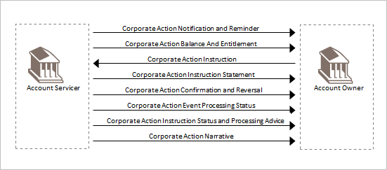

## Groups of MessageDefinitions and Functionality

1. These messages are to be used with the ISO 20022 Business Application Header (head.001). The schema and more information about the Business Application Header (BAH) can be found on the www.iso20022.org web site

### Groups

#### Notifications/Announcements, Entitlements and Cancellation

|  |  |  |
| --- | --- | --- |
| MessageDefinition | Abbreviated Name | Message Identifier |
| CorporateActionNotification | CANO | seev.031 |
| CorporateActionCancellationAdvice | CACN | seev.039 |
| CorporateActionNarrative | CANA | seev.038 |

#### Instructions and Cancellations

|  |  |  |
| --- | --- | --- |
| MessageDefinition | Abbreviated Name | Message Identifier |
| CorporateActionInstruction | CAIN | seev.033 |
| CorporateActionInstructionStatusAdvice | CAIS | seev.034 |
| CorporateActionInstructionCancellationRequest | CAIC | seev.040 |
| CorporateActionInstructionCancellationRequestStatusAdvice | CACS | seev.041 |
| CorporateActionInstructionStatementReport | CAST | seev.042 |

#### Movement Preliminary Advice and Cancellation

|  |  |  |
| --- | --- | --- |
| MessageDefinition | Abbreviated Name | Message Identifier |
| CorporateActionMovementPreliminaryAdvice | CAPA | seev.035 |
| CorporateActionMovementPreliminaryAdviceCancellationAdvice | CAPC | seev.044 |

#### Confirmation, Cancellation and Reversal

|  |  |  |
| --- | --- | --- |
| MessageDefinition | Abbreviated Name | Message Identifier |
| CorporateActionMovementConfirmation | CACO | seev.036 |
| CorporateActionEventProcessingStatusAdvice | CAPS | seev.032 |
| CorporateActionInstructionStatusAdvice | CARE | seev.037 |

### Functionality

See Message Definition Report Part 2 for the message scopes and formats.

# BusinessRoles and Participants

A BusinessRole represents an entity (or a class of entities) of the real world, physical or legal, a person, a group of persons, a corporation. Examples of BusinessRoles: “Financial Institution”, “Automated Clearing House”, “Central Securities Depository”.

A Participant is a functional role performed by a BusinessRole in a particular BusinessProcess or BusinessTransaction. Examples of Participants: the “user” of a system, “debtor”, “creditor”, “investor”.

The relationship between BusinessRoles and Participants is many-to-many. One BusinessRole can be involved as different Participants at different moments in time or at the same time. Examples of BusinessRoles: "user", "debtor”, "creditor", "investor". Different BusinessRoles can be involved as the same Participant.

In the context of corporate actions the high-level BusinessRoles and typical Participants can be represented as follows:

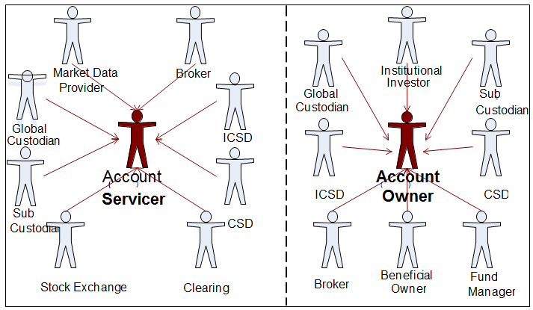

## Participants and BusinessRoles Definitions

Participants

|  |  |
| --- | --- |
| Description | Definition |
| Account Servicer | Party that manages the account on behalf of the account owner (that is, manages the registration and booking of entries on the account, calculates balances on the account and provides information about the account), or the party that has a contractual relationship with the owner (for example, market data provider). |
| Account Owner | Party that legally holds the account or the party in a contractual relationship with the servicer. |

Business Roles

|  |  |
| --- | --- |
| Description | Definition |
| Global Custodian | Party that safekeeps and administers assets on behalf of the owner and that has a network of sub-custodians. |
| Sub-Custodian | Party that safekeeps and administers assets on behalf of the owner |
| Stock Exchange | Place of trade identified with Market Identifier Code (MIC). |
| Issuer | Legal Entity that has the right to issue securities |
| Issuer Agent | Organisation appointed by the issuer for the purposes of administration of a security issue or processing of a corporate action or a meeting event. In some cases, the issuer acts as its own agent. |
| CSD / ICSD | Infrastructure that, holds or controls, the holding of physical or dematerialised financial instruments belonging to all, or a large portion of, the investors in a securities market. It effects the centralised transfer of ownership of such securities by entries on its books and records. The depository may delegate custody to another entity (custodian). |
| Market Data Provider | Source of financial information. It provides financial news and data (for example, facts, statistics and analysis), for professional and individual investors through various media (for example, the Internet, magazine). |
| Institutional Investor | Organisation whose primary purpose is to invest its own assets or those held in trust by it for others. Includes [investment companies](http://www.investorwords.com/2609/investment_company.html), [mutual funds](http://www.investorwords.com/3173/mutual_fund.html), [brokerages](http://www.investorwords.com/585/brokerage.html), [insurance companies](http://www.investorwords.com/6843/insurance_company.html), [pension funds](http://www.investorwords.com/3652/pension_fund.html), [investment banks](http://www.investorwords.com/2602/investment_bank.html). |
| Fund Manager | Entity that implements the investment strategy, that is, selects portfolio investments in accordance with the objectives and strategy in the fund's prospectus, and places orders to effect or liquidate selected investments in accordance with net flow of capital into or out of the fund. |
| Broker | Party that provides services to its members for the settlement of transactions and holding of assets. |
| Beneficial Owner | Person(s) or entity entitled to the benefits of ownership even through another party such as a broker or bank (the nominal owner) and actually has possession and title to the security. (Source: <http://www.rbeck.com>). |

## BusinessRoles and Participants Table

|  |  |  |
| --- | --- | --- |
| BusinessRole | Participant  Account Servicer | Participant  Account Owner |
| Global Custodian | X | X |
| Sub-Custodian | X | X |
| Stock Exchange | X |  |
| Clearing Agent | X |  |
| ICSD | X | X |
| CSD | X | X |
| Market Data Provider | X |  |
| Institutional Investor |  | X |
| Fund Manager |  | X |
| Broker | X | X |
| Beneficial Owner |  | X |

# BusinessProcess Description

This diagram represents the high level BusinessProcesses.

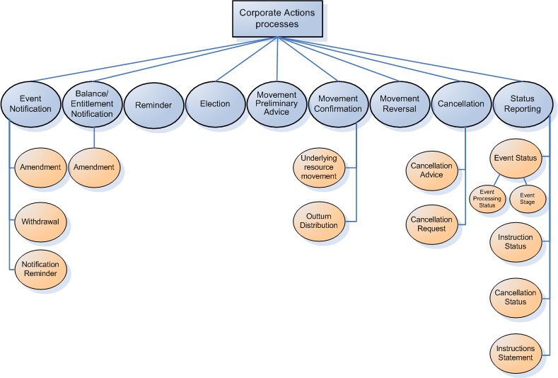

Event Notification

|  |  |
| --- | --- |
| Item | Description |
| Definition | The process of notifying the account owner of an upcoming corporate action. It provides corporate action details including options (if any). The notification is validated by the account servicer who then passes on the information to the account owner. A notification can also provide notification of updates, remind or advise of the withdrawal of a corporate action that was announced previously. |
| Trigger | * new corporate action event is announced * details of a previously announced corporate action have been changed * corporate action details were incorrect * new corporate action details are known * corporate action event has been withdrawn |
| Pre-conditions | Account servicer has been notified of a corporate action event by an external source, for example, sub-custodian, CSD, ICSD, market data vendor and financial publication |
| Post-conditions | Account owner is notified of the corporate action event |
| Role | Account servicer |

Eligibility / Entitlement Notification

|  |  |
| --- | --- |
| Item | Description |
| Definition | The process of providing the account owner with the balance of holdings eligible for a corporate action event and the entitlement to outturn resources. |
| Trigger | * new corporate action event is announced * details of a previously announced corporate action have been changed * corporate action details were incorrect * new corporate action details are known * corporate action event has been withdrawn |
| Pre-conditions | * account owner has eligible holdings or pending transactions in the corporate action event’s underlying security * corporate action is not withdrawn |
| Post-conditions | Account owner is informed of its eligible balance / entitlement |
| Role | Account servicer |

Reminder

This process is optional and agreed by SLA.

|  |  |
| --- | --- |
| Item | Description |
| Definition | The process of providing the account owners who have not instructed at all or fully instructed on their eligible balance for the corporate action event before the deadline |
| Trigger | No election response or partial election response was received |
| Pre-conditions | The account owner has not fully instructed or partially instructed. |
| Post-conditions | Account owner is informed that election instructions are missing or partial. |
| Role | Account servicer. |

Election

|  |  |
| --- | --- |
| Item | Description |
| Definition | The process of providing the account servicer with instructions on how the account owner wishes to proceed with the corporate action event. The account owner can request the cancellation of a previously sent corporate action instruction. |
| Trigger | * account owner has been advised of corporate action event details with sufficient details to respond * account owner has a standing instruction at the account servicer * account servicer instruction deadline, the default option can trigger the process. |
| Pre-conditions | Corporate action event is voluntary or mandatory with options and is not withdrawn |
| Post-conditions | Account servicer has the necessary details and instructions to carry out processing and transactions relating to the corporate action event |
| Role | Account owner |

Movement Preliminary Advice / Final Entitlement process

This process also includes the pre-advice of movement reversal (sent in order to give the account owner time to fund the reversal in its account). The process also includes the update/replacement of information previously provided.

|  |  |
| --- | --- |
| Item | Description |
| Definition | The process by which the account servicer pre-advises the account owner of upcoming postings to be made to its cash and/or securities account(s) as a result of a corporate action. |
| Trigger | Account servicer has the required information about the postings to be made |
| Pre-conditions | Postings of cash / securities have to be done the account owner’s account(s). |
| Post-conditions | None |
| Role | Account servicer |

Movement Confirmation

|  |  |
| --- | --- |
| Item | Description |
| Definition | The process of confirming that a corporate action event has been completed and that the appropriate postings to the account owner’s safekeeping account(s) have been effected. |
| Trigger | Securities or cash have been credited or debited to/from an account as the result of a corporate action event. |
| Pre-conditions | Postings of cash / securities are done to the account owner’s account(s) |
| Post-conditions | None |
| Role | Account servicer |

Movement Reversal

|  |  |
| --- | --- |
| Item | Description |
| Definition | The process of reversing the postings (cash and/or securities) made to the account owner’s safekeeping and /or cash accounts. It is to be noted that only full movement reversal can be done. |
| Trigger | * previous communication (notification or confirmation) due to calculation updates on the corporate action event (changes or updates in rates) * updates due to tax components that result in changes in confirmed distribution amounts as well as calculation errors |
| Pre-conditions | * previous movement confirmation must have been sent. * cash and/or securities postings are reversed in the account owner’s account(s) |
| Post-conditions | None |
| Role | Account servicer |

Cancellation

|  |  |
| --- | --- |
| Item | Description |
| Definition | Process by which the account servicer can advise the cancellation of a previously announced corporate action event or advise the cancellation of a previously sent corporate action movement preliminary advice, or by which the account owner can request the cancellation of an instruction. |
| Trigger | Previous communication is identified as inaccurate or void |
| Pre-conditions | Previous communication must have taken place |
| Post-conditions | None |
| Role | Account servicer / account owner |

Status Reporting

|  |  |
| --- | --- |
| Item | Description |
| Definition | The process of:   * providing the reason a corporate action event has not been completed by the announced payment dates * advising the status, or a change in status, of a corporate action-related transaction previously instructed by, or executed on behalf of, the account owner * advising the account owner of the processing status of a corporate action event * acknowledging or rejecting a corporate action instruction or acknowledging or rejecting a request to cancel an outstanding instruction * providing the account owner with statements of its instructed and uninstructed balances for all its corporate action events for a safekeeping account |
| Trigger | Execution of the various steps of the lifecycle of a corporate action event, when an account owner has sent an election instruction or requested the cancellation of a previously sent election instruction |
| Pre-conditions | Corporate action event must be on-going or an election instruction has been received by the account servicer |
| Post-conditions | None |
| Role | Account servicer. |

# Description of BusinessActivities

This section presents the different BusinessActivities within each BusinessProcess. The BusinessActivities of a process are described with activity diagrams.

Legend

|  |  |  |
| --- | --- | --- |
| Symbol | Name | Definition |
|  | Start Point | Shows where the lifecycle of the business process commences. |
|  | End Point | Shows where the lifecycle of the business process may ends. |
|  | Lozenge (or diamond) | Indicates that a choice between several actions can be made. |
|  | Bar | Indicates that several actions are initiated in parallel. |

## BusinessActivities Timeline

The business activity diagrams presented in this section are based on the basic corporate action events sequences time line as shown below. It is acknowledged that these sequences can differ from one event to another or that some of them can occur simultaneously depending on market rules or account servicer practices.

1. These timelines do not include cancellations and status reporting possibilities.

### Mandatory Corporate Action Events Sequence

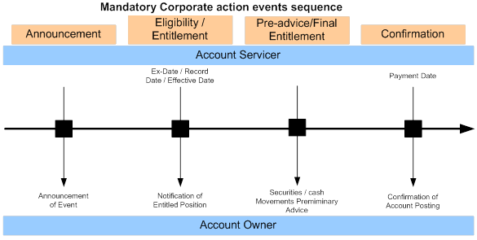

### Elective Corporate Action Events Sequence

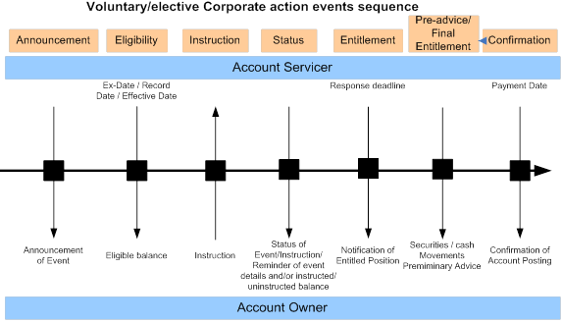

The process flows hereafter describe a possible high level sequence of the processes defined in the previous section 4.1.

The corporate actions process flows differ significantly between events with options and events without options. For this reason two process flows are presented here.

#### Mandatory Reorganisation without Options

This covers mandatory reorganisation without options (REOR/MAND) and mandatory distribution without options (DISN/MAND).

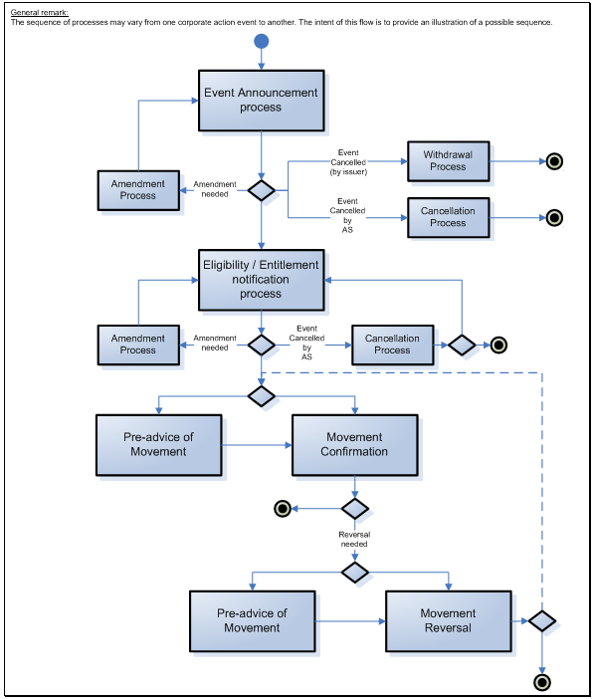

#### Mandatory Reorganisation with Options

This covers mandatory reorganisation with options (REOR/CHOS) and mandatory distribution with options (DISN/CHOS) and voluntary reorganisation (REOR/VOLU).

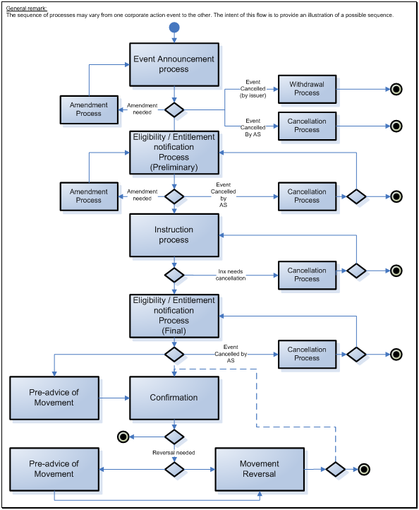

BusinessActivities

### Generic Corporate Action Process (Non Elective Event)

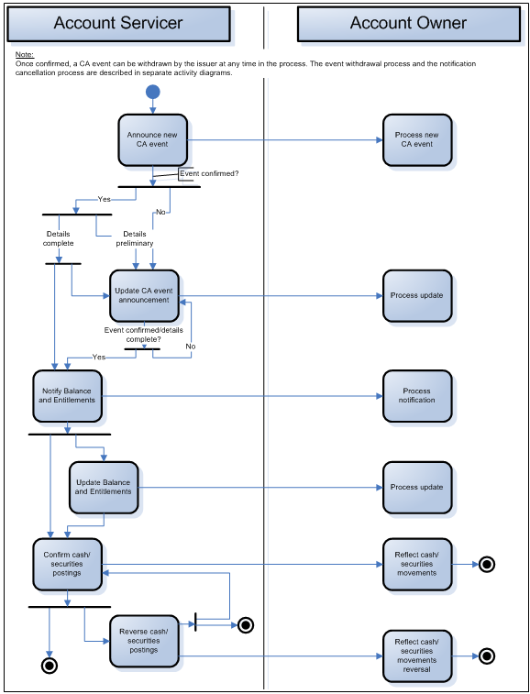

|  |  |  |
| --- | --- | --- |
| Step | Description | Initiator |
| Announce new CA event | The CA event is announced based on information received from the CSD, ICSD, market data provider, sub-custodian. | Account Servicer |
| Process new CA announcement | Processing of the new announcement. | Account Owner |
| Event confirmed? | If the CA event is confirmed on the market and details are complete, an update to the announcement may still be sent (if updates are received from an external source) or notification of balance and entitlements can take place.  If the CA event is confirmed and details are not complete (preliminary), an update to the CA event announcement may be sent.  If the CA event is not confirmed, details are by default preliminary, an update to the CA event announcement may be sent. | Account Servicer |
| CA announcement update | Processing of the announcement update | Account Owner |
| CA event is cancelled by account servicer | Processing of the cancellation | Account Owner |
| Notify Balance and Entitlements | Advise balance of holdings and entitlements.  Updated balance and entitlement advice may be provided. | Account Servicer |
| Notify Balance and Entitlements | Process balance and entitlements advice or updates. | Account Owner |
| Confirm cash/securities postings | When payment date is reached, cash/securities postings are confirmed. These postings may be reversed if necessary. | Account Servicer |
| Reflect cash/securities movement | Reflect cash/securities movements in internal accounts. | Account Owner |

Instruction Process (Elective Event)

This diagram only describes the instruction process (for event with voluntary events or mandatory events with options). In line, with the “Corporate Action Chronology of Events” figures, these activities typically occur between the corporate action announcement and the notification of balance and entitlements.



|  |  |  |
| --- | --- | --- |
| Step | Description | Initiator |
| Process Instruction | Process the received election instruction | Account Servicer |
| Instruct Election | Election instruction is sent to the account servicer based on the options proposed in the CA announcement | Account Owner |
| Reminder | If the response deadline is approaching or if a part of the account owner balance remains uninstructed, the account servicer may remind the account owner of the situation. | Account Servicer |
| Reminder | The account owner may do nothing or provide election for the part of the remaining part of the balance. | Account Owner |
| Instruction processed Yes/No | * Yes, go to 'Report Instruction Status' and go to the next activity (see Generic Corporate Action Process diagram). * No, go to 'Report Instruction Status' | Account Servicer |
| Report instruction status | Reports the status of the received election instruction. The status may be positive or negative. | Account Servicer |
| Process instruction status | Process the instruction status report. | Account Owner |
| Instruction status OK? | If No, no further action or go to Instruct election process. If Yes, end of activities. | Account Owner |

### Instruction Cancellation Request Process (Elective Event)



|  |  |  |
| --- | --- | --- |
| Step | Description | Initiator |
| Process cancellation request | Processes the cancellation request. | Account Servicer |
| Request cancellation of instruction | The account owner may request the cancellation of a previously sent election instruction. | Account Owner |
| Request accepted Yes/No | * Yes: report cancellation request status to the account owner and go to Notify balance and entitlements process (see Generic corporate action diagram) * No: report cancellation request status to the account owner | Account Servicer |
| Process cancellation request status | If status is OK, the account owner may do nothing or re-instruct with new election.  If status is not OK (that is, cancellation request rejected), no further activities. | Account Owner |

### Reminder Process



|  |  |  |
| --- | --- | --- |
| Step | Description | Initiator |
| Reminder | Provide a reminder of the event details and/or instructed/uninstructed balance for a previously announced corporate action event. | Account Servicer |
| Process reminder | Process the reminder. | Account Owner |

### Instruction Reporting Process



|  |  |  |
| --- | --- | --- |
| Step | Description | Initiator |
| Missing instructions reporting process | Report instructed/uninstructed balance for one or more previously announced corporate action event at the level of the safekeeping account for one or more Safekeeping account. | Account Servicer |
| Process missing instructions report | Process missing instructions report. | Account Owner |

### Movement Preliminary Advice Process



|  |  |  |
| --- | --- | --- |
| Step | Description | Initiator |
| Movement preliminary advice | Pre-advise the account owner of an upcoming posting of securities and/or cash resulting from a previously announced corporate action event. | Account Servicer |
| Process movement preliminary advice | Process movement preliminary advice. | Account Owner |

Movement Preliminary Advice Cancellation Process

This process applies for the cancellation of a previously sent movement preliminary advice from the account servicer to the account owner.



|  |  |  |
| --- | --- | --- |
| Step | Description | Initiator |
| Corporate Action movement preliminary advice cancellation | Advise the account owner that a previously sent movement preliminary advice has been cancelled. | Account Servicer |
| Process cancellation | Process the corporate action movement preliminary advice cancellation. | Account Owner |

### Corporate Action Event Withdrawal Process



|  |  |  |
| --- | --- | --- |
| Step | Description | Initiator |
| Corporate Action withdrawal process | Advise the account owner that a previously announced corporate action has been withdrawn by the issuer. | Account Servicer |
| Process Corporate Action withdrawal | Process corporate action withdrawal: the account owner processes the corporate action withdrawal. | Account Owner |

### Corporate Action Narrative Process

The Corporate Action Narrative message is a bidirectional message and is restricted to specific cases, for instance, for communicating tax details or certification / registration details.

# BusinessTransactions

This section describes the message flows based on the activity diagrams documented above. It shows the typical exchanges of information in the context of a BusinessTransaction.

The corporate action messages are exchanged between business actors acting either as an account servicer, for example, ICSDs, CSDs, global custodians or clearing agents, or as an account owner, for example, fund managers or institutional investors.

If there are intermediaries in the corporate action processing chain between the issuer (agent) and the end investor, some of the business actors, for example, ICSDs, CSDs, global custodians or sub-custodians, will play the account servicer role in one part of the message flow and then, in the next part of the message flow, play the account owner role. In order to keep the generic nature of the message flows described hereafter, only the roles account servicer and account owner will be used.

## Announcement and Entitlement

The scenarios in this section illustrate the corporate action messages flow during the corporate action event announcement and entitlement phases.

### Announcement

This scenario illustrates a classical sequence of corporate action messages for the announcement phase of a corporate action event. However, depending on the type of corporate action event and on its processing evolution during its life cycle, not all messages illustrated here will necessarily be sent.

The account servicer sends a new CorporateActionNotification to the account owner as a preliminary announcement of a corporate action event concerning a security in which the account owner has holdings on its account. As the event details communicated to the account Servicer are updated or modified, the account servicer may send other replacement CorporateActionNotification messages indicating each time the processing status of the event.

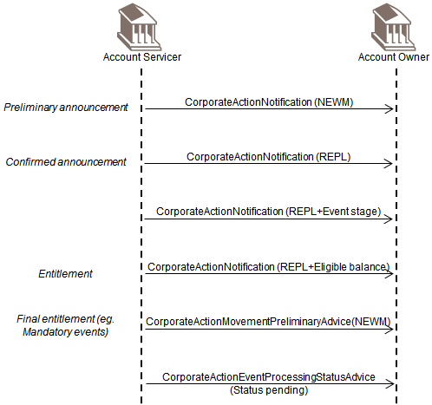

Once the information about the corporate action event is complete and confirmed, the account servicer sends a replacement CorporateActionNotification to the account owner as a confirmed announcement indicating the status is complete and confirmed.

If appropriate for the corporate action event, the account servicer may send a replacement CorporateActionNotification containing the information on the event stage reached in the corporate action event life cycle.

For corporate action events having an entitlement date (for example, stock dividend), the account servicer sends on entitlement date an entitlement CorporateActionNotification containing the eligible balance and possibly resulting securities and/or cash movements to the account servicer.

For corporate action events that have an entitlement date and that do not require an election phase (for example, mandatory events without options), once the entitlement date is reached, the account servicer may send a CorporateActionMovementPreliminaryAdvice containing the final entitlements and movements to the account owner.

In the case of plain vanilla predictable events such as an interest payment, a preliminary announcement and a confirmed announcement are not always necessary and therefore the related CorporateActionNotification messages may not necessarily be sent by the account servicer. The account servicer might directly send a final entitlement CorporateActionMovementPreliminaryAdvice message to the account owner as a first message concerning this type of corporate action event (see also section 2 about election, entitlement and reminder).

Should a corporate action event processing not be fully completed by the announced payment date, the account servicer may send a CorporateActionEventProcessingStatusAdvice to the account owner to inform about the processing status and optionally, the reason for this status.

### Announcement and Cancellation of Event

This scenario illustrates a classical sequence of corporate action messages when a corporate action event is withdrawn by the issuer after having been previously announced through the chain of intermediaries and possibly to the end investor.

The account servicer sends a CorporateActionNotification to the account owner as an announcement of a corporate action event concerning a security in which the account owner has holdings on its account.

Once the account servicer has been informed that the corporate action event is withdrawn by the Issuer, the account servicer sends a CorporateActionCancellationAdvice to the account owner with the cancellation reason indicating a withdrawal of the event.

A corporate action event may be withdrawn by the Issuer at any moment during its life cycle. It is possible that CorporateActionCancellationAdvice is sent after several replacement CorporateActionNotification or CorporateActionMovementPreliminaryAdvice messages have been sent or even after the election phase of an event.

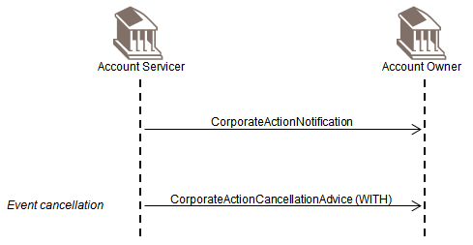

### Announcement and Cancellation due to Processing Error

This scenario illustrates a classical sequence of corporate action messages when a corporate action event is cancelled by the account servicer after having been previously but erroneously announced to the account owner. This might happen when the account servicer sends announcement messages to the account owner whilst for instance it has no holdings in the security concerned by the corporate action event announced.

The account servicer sends a new CorporateActionNotification to the account owner as a preliminary announcement of a corporate action event concerning a security in which the account owner has for instance no holdings on its account.

Once the account servicer notices that the account owner should not have been informed about this corporate action event, the account servicer sends a CorporateActionCancellationAdvice to the account owner with the cancellation reason indicating a processing error.

Note also that it is likely that a CorporateActionCancellationAdvice is sent only after several replacement CorporateActionNotification or a CorporateActionMovementPreliminaryAdvice have been sent, should the account servicer not notice its mistake immediately.

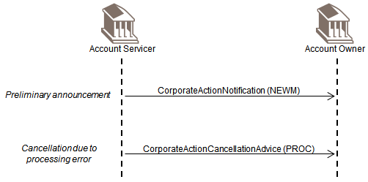

### Final Entitlement Replacement Scenario

This scenario illustrates a case where a replacement of a final entitlement takes place.

In the case of a mandatory corporate action event, after the sending of one or more preliminary announcement and of a confirmed announcement, the account servicer may send a new CorporateActionMovementPreliminaryAdvice containing the final entitlements and movements to the account owner.

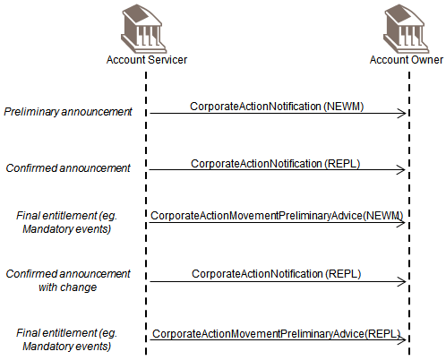

After this, if one or more information element in the corporate action event details are modified by the issuer and may affect the eligible balance and/or the movements details, the account servicer sends a replacement CorporateActionNotification with the updated information as a second confirmed announcement.

Following this, the account servicer also sends a replacement CorporateActionMovementPreliminaryAdvice to the account owner to confirm the updated entitlements and movements.

## Election, Entitlement and Reminder Scenarios

The scenarios developed in this section illustrate the corporate action messages flow during the corporate action event election phase of an elective corporate action event. Non-elective corporate action events will not go through this phase but will directly enter the confirmation phase after the announcement is completed.

In order to illustrate the election phase in its context, the announcement phase of the corporate action event life cycle has also been represented in the following sequence diagrams with preceding preliminary announcement and confirmed announcement messages.

### Election and Final Entitlement

This scenario illustrates a classical sequence of corporate action messages for the election phase of a corporate action event following the announcement phase when a single instruction is sent by the account owner.

Once the announcement phase is completed, the account owner may send a CorporateActionInstruction to the account servicer to instruct on one of the proposed options and for a part or all of its eligible balance.

Once the instruction has been processed by the account servicer, the account servicer sends a CorporateActionInstructionStatusAdvice to the account owner to report the status of the instruction processing. If the instruction is accepted, the account servicer may then also send a CorporateActionMovementPreliminaryAdvice containing the final entitlements and movements to the account owner.

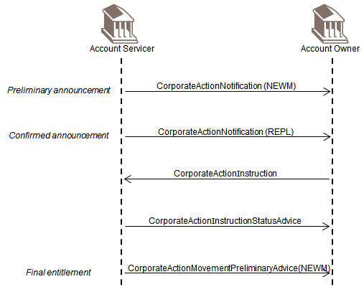

### Election and Final Entitlement Cancellation Scenario

This scenario illustrates a classical sequence of corporate action messages for the election phase of a corporate action event following the announcement phase when an instruction may be cancelled by the account owner Once the announcement phase is completed, the account owner may send a CorporateActionInstruction to the account servicer to instruct on one of the proposed options and for a part or all of its eligible balance.

Once the instruction has been processed by the account servicer, the account servicer sends a CorporateActionInstructionStatusAdvice to the account owner to report the status of the instruction processing. If the instruction is accepted, the account servicer may then also send a CorporateActionMovementPreliminaryAdvice containing the final entitlements and movements to the account owner.

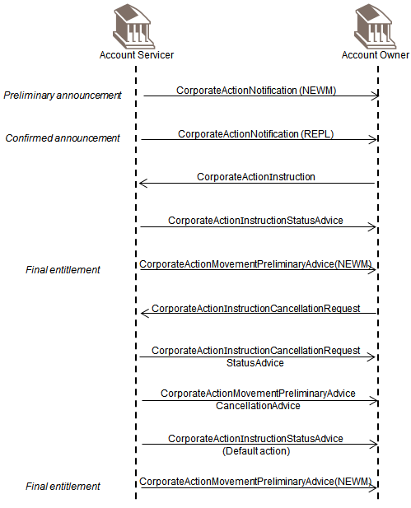

If the cancellation of the instruction is permitted for the corporate action event and the account owner wants to cancel its instruction, the account owner sends a CorporateActionInstructionCancellationRequest to the account servicer and it may indicate in the message whether a new instruction will be sent later on to instruct on the proposed options.

Once the instruction cancellation has been processed by the account servicer, the account servicer sends a CorporateActionInstructionCancellationRequestStatusAdvice to the account owner to report the status of the instruction cancellation processing.

If no other instruction is sent by the account owner before the instruction deadline set by the account servicer, and there is no standing instruction defined by the account owner, the account servicer sends a CorporateActionInstructionStatusAdvice to the account owner indicating that the default action defined for the event was taken into account for the election process.

The account servicer may then also send a CorporateActionMovementPreliminaryAdvice containing the final entitlements and movements to the account owner.

### Election and Final Entitlement Replacement

This scenario illustrates a classical sequence of corporate action messages for the election phase of a corporate action event following the announcement phase when the account owner instructs first partially and later on sends a second instruction to instruct the remaining part of the eligible balance.

Once the announcement phase is completed, the account owner may send a CorporateActionInstruction to the account servicer to instruct on one of the proposed options and for a part or all of its eligible balance.

Once the instruction has been processed by the account servicer, the account servicer sends a CorporateActionInstructionStatusAdvice to the account owner to report the status of the instruction processing. If the instruction is accepted, the account servicer may then also send a CorporateActionMovementPreliminaryAdvice containing the final entitlements and movements to the account owner.

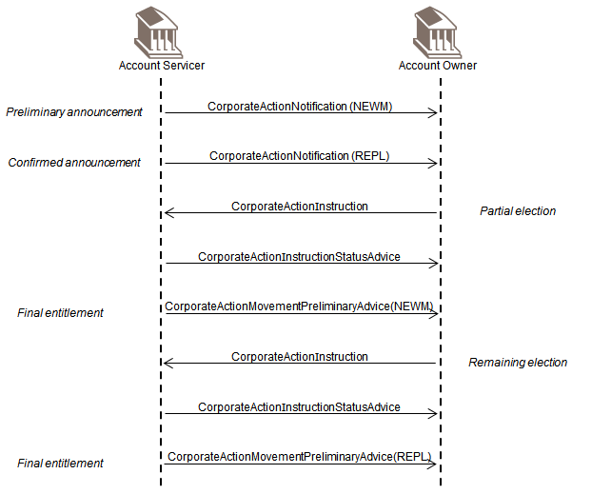

If the account owner then sends a second CorporateActionInstruction to the account servicer to instruct the remaining part of its eligible balance, and the instruction is accepted too, the account servicer sends a CorporateActionInstructionStatusAdvice to the account owner with a status "accepted". The account servicer then should also send a replacement CorporateActionMovementPreliminaryAdvice containing the updated final entitlement and movements to the account owner.

### Reminder

This scenario illustrates a classical sequence of corporate action messages for the election phase of a corporate action event following the announcement phase when the account servicer reminds the account owner that it may instruct on the proposed options of the concerned corporate action event.

Once the announcement phase is completed, and the account owner has not yet instructed for any of the option for its eligible balance whilst the instruction deadline set by the account servicer is approaching, the account servicer may send a reminder CorporateActionNotification to the account owner to remind him about the corporate action event details, its eligible balance and proposed options.

The account owner may then send to the account servicer its instruction within the CorporateActionInstruction so that the election process can continue until completion.

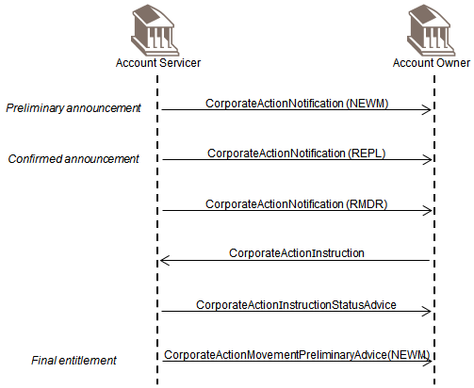

## Confirmation and Reversal

The scenarios developed in this section illustrate the corporate action messages flow during the corporate action confirmation and reversal phases. For non-elective corporate action events, this phase comes directly after the announcement and final entitlement phases. For elective corporate action events, this phase comes directly after the election phase.

In order to illustrate the confirmation and reversal phases in their context, the announcement and election phases of the corporate action event life cycle have also been represented in the following sequence diagrams with preceding preliminary and confirmed announcement messages and instruction and instruction status messages.

### Confirmation

This scenario illustrates a classical sequence of corporate action messages for the confirmation phase of a corporate action event following the announcement and election phases.

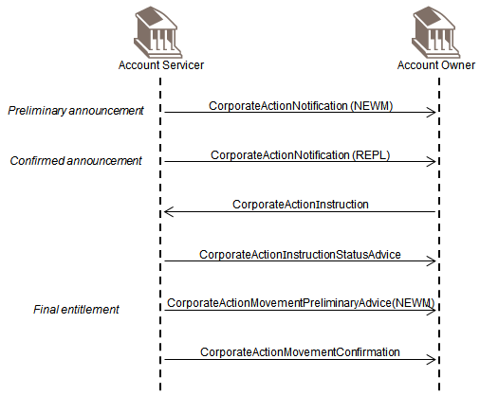

Once the announcement phase and the election phase (in the cases of elective corporate action events) are completed, the account servicer may send a CorporateActionMovementPreliminaryAdvice containing the final entitlements and movements to the account owner so as to pre-advise him about the upcoming securities and/or cash movements. The account servicer must also send a CorporateActionConfirmation to the account owner to confirm that the cash and/or securities have been credited and/or debited from/to its account.

### Reversal

This scenario illustrates a classical sequence of corporate action messages for the confirmation and phase of a corporate action event when a reversal occurs.

Once the announcement phase and the election phase (in the cases of elective corporate action events) are completed and the account servicer has confirmed to the account owner that the movements have been applied on its account, and for some reasons, the movements must be reversed, the account servicer may optionally send a reversal CorporateActionMovementPreliminaryAdvice to the account owner to pre-advise him that the securities and/or cash movements are going to be reversed. The account servicer may also indicate the reason for the reversal.

The account servicer must also send a CorporateActionMovementReversalAdvice to the account owner to confirm the reversal of the movements have been carried out. The account servicer may also indicate the reason for the reversal into the CorporateActionMovementReversalAdvice.

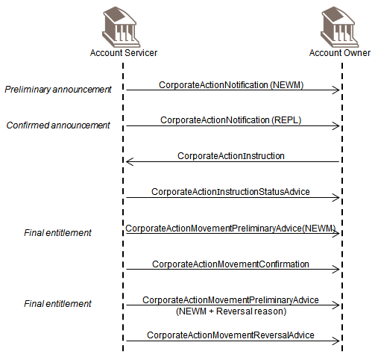

### Reversal Pre-Advice Cancellation

This scenario illustrates a classical sequence of corporate action messages for the confirmation and phase of a corporate action event when a cancellation of a reversal pre-advice occurs.

Once the announcement phase and the election phase (in the cases of elective corporate action events) are completed and the account servicer has confirmed to the account owner that the movements have been applied on its account, and for some reasons, the movements must be reversed, the account servicer may optionally send a reversal CorporateActionMovementPreliminaryAdvice to the account owner to pre-advise him that the securities and/or cash movements are going to be reversed. The account servicer may also indicate the reason for the reversal.

If it finally comes out after this that the movements will not be reversed, the account servicer must cancel the reversal pre-advice by sending a CorporateActionMovementPreliminaryAdviceCancellationAdvice to the account owner to confirm the cancellation of the announced reversal of the movements.

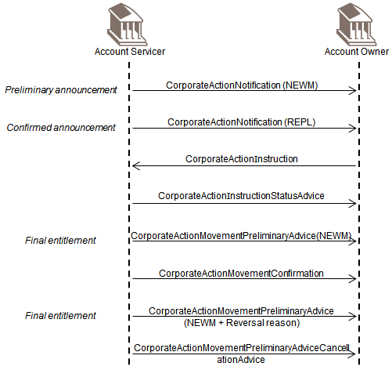

## Instruction Reporting

The account servicer may send a CorporateActionInstructionStatementReport to the account owner at any time to report about the instructed, uninstructed and other balances for one or more corporate action events at a safekeeping account level or to report about the instructed, uninstructed and other balances for one corporate action event but for one or several safekeeping accounts in which the account owner has holdings.

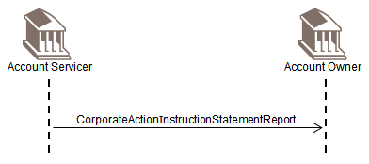

## Narrative

The account owner or the account servicer may send the CorporateActionNarrative message to provide specific narrative information for taxation conditions, registration details, confirmation of holdings transfer and other ancillary processes.

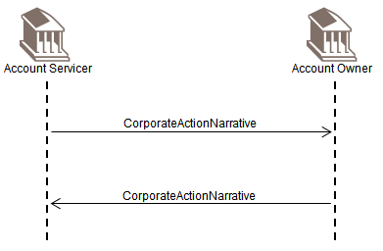

## Movement Preliminary Advice – Detailed Usage in Typical CA Business Scenarios

### Introduction

This section provides more detailed usage rules and business flows for the preliminary advice and preliminary advice cancellation processes outlined in the 2 previous sections above.

### Business Need

Corporate Action Movement Preliminary Advice messaging addresses three key business needs:

1. Facilitate automated payment processing and payment management

The CA Movement Preliminary Advice is the building block for payment automation, it will allow for the message to interface automatically into payment processing systems and identify pre-matching of payments which will result in increased payment STP.

1. Increase efficiency

Custodians and clients could benefit from a CA Movement Preliminary Advice message that confirms payment details. The CA Movement Preliminary Advice message will report all critical details of corporate action payments at the account level within structured tags incorporating tax treatment information, rates, commissions, and fees. The CA Movement Preliminary Advice message can be linked to the CA Movement Confirmation message and achieve reconciliation at the account, tax profile, and specific transaction level.

1. Reduce operational risk

In ISO 15022, the practice of using MT 564 for announcement of updated event details commingled with Movement Preliminary Advice of payment details is problematic. From an Event Management perspective, critical updates of event details could be missed if the MT 564 is perceived to be sent for final entitlement and/or cash reconciliation purposes. Similarly, the client could potentially miss Movement Preliminary Advice details needed to facilitate cash projections if the MT 564 is perceived to be for event or entitlement update details.

### Usage Rules

The CA Movement Preliminary Advice message is an optional message within the Corporate Action message flow and can be used for actions in all event categories; Mandatory, Mandatory with Election, and Voluntary events.

#### Mandatory Events

The CA Movement Preliminary Advice can be sent for credit/debit of cash and/or securities. It would be triggered prior to the payment date of the event and may or may not follow an ISO 20022 CA Notification message.

Some common examples of cases where the CA Movement Preliminary Advice would be used include Mandatory Income as well as Mandatory Capital events such as: Cash Dividends, Interest Payments, Maturity Payments / Final Redemptions, Partial Redemptions, CMO Payments, Stock Dividends, Stock Splits/Reverse Splits, Return of Capital, Merger (the list is not exhaustive).

CA Movement Preliminary advice can be sent as a stand-alone message (i.e. not linked to a CA Notification) only in the case of predictable events (Interest payment, maturity payment, …).

#### Mandatory with Election and Voluntary Events

ISO 20022 CA Movement Preliminary Advice can be sent as the communication method for Final Entitlement replacing the CA Notification message for this purpose. The CA Movement Preliminary Advice for Mandatory with Election and Voluntary events can be sent for credit/debit of cash and/or securities upon confirmation of the instruction. This is consistent with the current market practice of final entitlement.

The Movement Preliminary Advice is formatted with all the movements associated with the option, even though more than one final confirmation of payment message may have to be sent depending on posting dates.

For instance, in the case of a Rights Issue where the Exercise option is elected, the Movement Preliminary Advice will identify the following movements; Cash Debit Movement, Share Credit Movement, and Share Debit Movement.

However, several final payment confirmations (in an ISO 20022 CA Confirmation messages) may have to be sent as the payment dates may be different for each movement.

#### Replacement Preliminary Movement Advice

In the case where resulting entitlement is updated, and a Movement Preliminary Advice has been sent to the account owner, it is recommended that a replacement Movement Preliminary Advice be triggered upon recalculation of the entitlement as long as cash and/or securities have not been posted to the clients account.

Examples

* Critical data element has changed at the event level which affects the resulting cash and/or securities entitlement.
* Regarding Final Entitlement, when an offer is pro-rated – At this point the resulting entitlement has been recalculated as a critical data element has changed at the offer level. The account owner is pre-advised of the new cash and/or securities movements.

#### Cancellation of a Preliminary Movement Advice

* When an election instruction is cancelled - At this point the resulting entitlement has been recalculated to zero and the service provider may send a cancellation of the Movement Preliminary Advice to convey that the movements have been taken down.
* A Movement Preliminary Advice can be sent to pre-advise of a reversal of corporate action cash or securities postings. If the CA Confirmation Reversal does not finally take place, this pre-advice of movement reversal may be cancelled by the account servicer.

### Business Scenarios

#### Scope

The following scenario are to be considered as examples illustrating how a Corporate Action Movement Preliminary Advice fits in to the Corporate Action message flow for actions within each event category.

Since a lot of aspects of the message flows may be governed by specific service level agreements defined between counterparties, these diagrams cannot and do not intend to reflect all the possible cases of message flows. They usually illustrate the plain vanilla scenario within each category and therefore are to be used only as guidance for implementers.

#### Conventions used in flow diagrams

The message flow diagrams are colour coded for ease of reference with the following conventions:

Black = Mandatory message flow

Blue = Optional message flow

Orange = Movement Preliminary Advice and Cancellation Advice message flow

|  |  |
| --- | --- |
| Message or Field Abbreviated Name | Message |
| MT 564 | ISO 15022 Corporate Action Notification message |
| MT565 | ISO 15022 Corporate Action Instruction message |
| MT566 | ISO 15022 Corporate Action Confirmation message |
| MT 567 | ISO 15022 Corporate Action Status and Processing Advice message |
| 23G::NEWM | ISO 15022 Function of the Message field with value “New” message |
| 23G::REPE | ISO 15022 Function of the Message field with value “Eligible Balance Notification” message |
| 23G::REPL | ISO 15022 Function of the Message field with value “Replacement” message |
| 25D::PROC//PREC | ISO 15022 Processing Status field with value “Preliminary Announcement Confirmed” |
| 25D::PROC//COMP | ISO 15022 Processing Status field with value “Complete” |
| 25D::IPRC//PACK | ISO 15022 Status Code field with status value “Instruction Processing Status Acknowledge/Accepted” |
| CANO | ISO 20022 Corporate Action Notification message |
| CAPS | ISO 20022 Corporate Action Event Processing Status Advice message |
| CAIN | ISO 20022 Corporate Action Instruction message |
| CAIS | ISO 20022 Corporate Action Instruction Status Advice message |
| CAPA | ISO 20022 Corporate Action Movement Preliminary Advice message |
| CACO | ISO 20022 Corporate Action Movement Confirmation message |
| CARE | ISO 20022 Corporate Action Movement Reversal Advice message |
| CANA | ISO 20022 Corporate Action Narrative message |
| CACN | ISO 20022 Corporate Action Cancellation Advice message |
| CAIC | ISO 20022 Corporate Action Instruction Cancellation Request message |
| CACS | ISO 20022 Corporate Action Instruction Cancellation Request Status Advice message |
| CAST | ISO 20022 Corporate Action Instruction Statement Report message |
| CAPC | ISO 20022 Corporate Action Movement Preliminary Advice Cancellation Advice message |

#### Scenario 1: Mandatory Event – No Preliminary Advice

This scenario illustrates, using an ISO 150022 notation, a classic business flow for mandatory corporate action events when a preliminary advice flow is not explicitly supported.

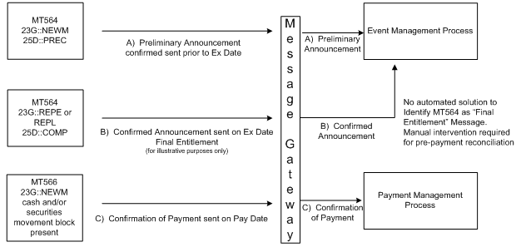

Scenario 2: Mandatory with Election and Voluntary Event - No Preliminary Advice

This scenario illustrates, using an ISO 150022 notation, a classic business flow for mandatory corporate action events with election or voluntary corporate action events when a preliminary advice flow is not explicitly supported.

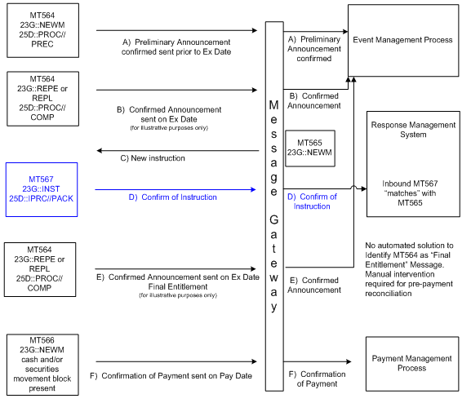

#### Scenario 3: Mandatory Event Ex Date = Pay Date

The account servicer announces a mandatory event with a payment date on the same day as the ex-date. A CA Movement Preliminary Advice is sent prior to ex-date and payment date.



#### Scenario 4: Mandatory Event

The account servicer announces a mandatory event. A CA Movement Preliminary Advice is sent prior to payment date

Scenario 5: Mandatory Event with Reversal of Payment

The account servicer announces a mandatory event. A CA Movement Preliminary Advice is sent prior to payment date. Following confirmation of the payment, a reversal needs to be made for which a CA Movement Preliminary Advice of reversal is made prior to the effective reversal of payment.



CAPA and CACO Movements usage guidelines

Movements reported within the CA movement preliminary advice reversal (CAPA reversal) message will be opposite to those reported into the referred CA confirmation message (CACO) i.e. credit of cash and/or securities will become debits and inversely.

Movements reported within the CA Reversal (CARE) message will be identical to the movements reported into the referred CA confirmation message (CACO).

1. If a rebook follows a reversal, it is recommended that the rebook be considered a new payment. Therefore, subject to the pre-advice process if it meets the criteria agreed upon between the account servicer and the account provider.

#### Scenario 6: Mandatory Event with Cancelled Reversal of Payment

The account servicer announces a mandatory event. A CA Movement Preliminary Advice is sent prior to payment date. Following confirmation of the payment, a reversal needs to be made for which a CA Movement Preliminary Advice of reversal is sent. This CA Movement Preliminary Advice of reversal is eventually cancelled.



Scenario 7: Mandatory Event with Critical Update

The account servicer announces a mandatory event. A CA Movement Preliminary Advice is sent prior to payment date. Following this advice, a critical update is sent by the account servicer, followed by an updated CA Movement Preliminary Advice.



#### Scenario 8: Mandatory with Election and Voluntary Event - New Instruction

The account servicer announces a mandatory with election or a voluntary event. A CA Movement Preliminary Advice is sent to the account owner after receipt of its corporate action instruction.



Scenario 9: Mandatory with Election Event - Cancel Instruction

The account servicer announces a mandatory with election or a voluntary event. A CA Movement Preliminary Advice is sent to the account owner after receipt of its corporate action instruction. The account owner subsequently cancels its corporate action instruction. The acceptance of the corporate action instruction cancellation by the account servicer is followed by the sending of a CA Movement Preliminary Advice Cancellation Advice. After the instruction deadline, a CA Movement Preliminary Advice is sent to the account owner followed by a CA Movement Confirmation.



#### Scenario 10: Mandatory with Election – No Instruction Received

The account servicer announces a mandatory with election event. The account owner does provide corporate action instructions therefore (depending on the type of service provided) the account owner sends either a CA Notification with function Reminder. After the deadline the account servicer sends a CA Instruction Status Advice to advice the account owner that the default instruction has been applied to its holdings. A CA Movement Preliminary Advice is finally sent to the account owner followed by a CA Movement Confirmation.



#### Scenario 11: Voluntary Event – Cancel and Rebook Instruction

The account servicer announces a voluntary event. The account servicer sends a CA Movement Preliminary Advice message to the account owner following the receipt of its corporate action instruction. The account owner cancels its corporate action instruction. The account servicer then cancels the sent CA Movement Preliminary Advice message and sends a new CA Movement Preliminary Advice message following the receipt of the new corporate action instruction from the account owner.



#### Scenario 12: Voluntary Event – Partial Election

The account servicer announces a voluntary event for which two consecutive partial corporate action instructions are received from the account owner. The account servicer sends a CA Movement Preliminary Advice following each corporate action instruction received.



1. Regarding split elections between options, it is understood that since one CA Confirmation is sent per elected option, a separate CA Movement Preliminary Advice message will be sent for each option elected.

#### Scenario 13: Movement Preliminary Advice for Market Claim & Compensation and Tax Refund

A. Market Claim & Compensation



B. Tax Refund



C. Movement Preliminary Advice Cancellation for Market Claim & Compensation



D. Movement Preliminary Advice Cancellation for Tax Refund



# Business Examples

This section describes business examples of the use of the MessageDefinitions.

These examples are valid for both "001" and "002" variants.

## CorporateActionNotification seev.031.00x.12

Description

This example describes a CorporateActionNotification sent by an account servicer containing the initial announcement of a dividend option event for which the event details are complete, the event is confirmed and the eligible balance provided.

The corporate action event is a distribution of a dividend to shareholders with a choice of benefit to receive. Shareholders may choose to receive shares, cash. To be distinguished from DRIP as the company creates new share capital in exchange for the dividend rather than investing the dividend in the market.

Business Data

Issue name

Glaxo Holdings

ISIN GB0007123466

Terms

Final dividend of GBP 0,017 per share, OR one ordinary share for every 37 shares held. Elections cannot be made on holdings of less than 37 shares.

Elections which give rise to fractional entitlements will be rounded down to the nearest whole multiple of 37 shares; the full cash dividend of GBP 0,017 per share will be paid on the remainder of the holding.

Relative dates

Ex date - 01 September 2010

Record date - 07 September 2010

Dividend payment date - 02 October 2010

Response deadline date - 23 September 2010

Transaction description

A/C 98-0112441-05 has an underlying balance of 80.000 shares.

**Message Instance (with application header)**

<AppHdr xmlns="urn:iso:std:iso:20022:tech:xsd:head.001.001.02" xmlns:n1="http://www.w3.org/2000/09/xmldsig#">

<Fr>

<FIId>

<FinInstnId>

<BICFI>ABCDBEBBXXX</BICFI>

</FinInstnId>

</FIId>

</Fr>

<To>

<FIId>

<FinInstnId>

<BICFI>WXYZFRPP666</BICFI>

</FinInstnId>

</FIId>

</To>

<BizMsgIdr>LOCCUS000000001</BizMsgIdr>

<MsgDefIdr>seev.031.001.11</MsgDefIdr>

<CreDt>2010-08-15T09:30:00Z</CreDt>

</AppHdr>

<Document xmlns="urn:iso:std:iso:20022:tech:xsd:seev.031.001.12" xmlns:xsi="http://www.w3.org/2001/XMLSchema-instance">

<CorpActnNtfctn>

<NtfctnGnlInf>

<NtfctnTp>NEWM</NtfctnTp>

<PrcgSts>

<Cd>

<EvtCmpltnsSts>COMP</EvtCmpltnsSts>

<EvtConfSts>CONF</EvtConfSts>

</Cd>

</PrcgSts>

<ElgblBalInd>true</ElgblBalInd>

</NtfctnGnlInf>

<CorpActnGnlInf>

<CorpActnEvtId>DIVGLAX123</CorpActnEvtId>

<OffclCorpActnEvtId>BI01593212345</OffclCorpActnEvtId>

<EvtTp>

<Cd>DVOP</Cd>

</EvtTp>

<MndtryVlntryEvtTp>

<Cd>CHOS</Cd>

</MndtryVlntryEvtTp>

<UndrlygScty>

<FinInstrmId>

<ISIN>GB0007123466</ISIN>

<Desc>GLAXO HOLDINGS</Desc>

</FinInstrmId>

</UndrlygScty>

</CorpActnGnlInf>

<AcctDtls>

<AcctsListAndBalDtls>

<SfkpgAcct>98-0112441-05</SfkpgAcct>

<Bal>

<TtlElgblBal>

<Bal>

<QtyChc>

<SgndQty>

<ShrtLngPos>LONG</ShrtLngPos>

<Qty>

<Unit>80000</Unit>

</Qty>

</SgndQty>

</QtyChc>

</Bal>

</TtlElgblBal>

</Bal>

</AcctsListAndBalDtls>

</AcctDtls>

<CorpActnDtls>

<DtDtls>

<RcrdDt>

<Dt>

<Dt>2010-09-07</Dt>

</Dt>

</RcrdDt>

<ExDvddDt>

<Dt>

<Dt>2010-09-01</Dt>

</Dt>

</ExDvddDt>

</DtDtls>

<DvddTp>

<Cd>FINL</Cd>

</DvddTp>

</CorpActnDtls>

<CorpActnOptnDtls>

<OptnNb>001</OptnNb>

<OptnTp>

<Cd>CASH</Cd>

</OptnTp>

<DfltPrcgOrStgInstr>

<DfltOptnInd>true</DfltOptnInd>

</DfltPrcgOrStgInstr>

<DtDtls>

<MktDdln>

<Dt>

<Dt>2010-09-24</Dt>

</Dt>

</MktDdln>

<RspnDdln>

<Dt>

<DtTm>2010-09-23T15:00:00</DtTm>

</Dt>

</RspnDdln>

</DtDtls>

<RateAndAmtDtls>

<GrssDvddRate>

<Amt Ccy="GBP">0.017</Amt>

</GrssDvddRate>

</RateAndAmtDtls>

<CshMvmntDtls>

<CdtDbtInd>CRDT</CdtDbtInd>

<DtDtls>

<PmtDt>

<Dt>

<Dt>2009-10-02</Dt>

</Dt>

</PmtDt>

</DtDtls>

</CshMvmntDtls>

</CorpActnOptnDtls>

<CorpActnOptnDtls>

<OptnNb>002</OptnNb>

<OptnTp>

<Cd>SECU</Cd>

</OptnTp>

<FrctnDspstn>

<Cd>CINL</Cd>

</FrctnDspstn>

<DfltPrcgOrStgInstr>

<DfltOptnInd>false</DfltOptnInd>

</DfltPrcgOrStgInstr>

<FinInstrmId>

<ISIN>GB0007633421</ISIN>

<Desc>GLAXO WELLCOME</Desc>

</FinInstrmId>

<DtDtls>

<MktDdln>

<Dt>

<Dt>2010-09-24</Dt>

</Dt>

</MktDdln>

<RspnDdln>

<Dt>

<DtTm>2010-09-23T15:00:00</DtTm>

</Dt>

</RspnDdln>

</DtDtls>

<SctiesMvmntDtls>

<SctyDtls>

<FinInstrmId>

<ISIN>GB0007633421</ISIN>

<Desc>GLAXO WELLCOME</Desc>

</FinInstrmId>

</SctyDtls>

<EntitldQty>

<Qty>

<Unit>2162</Unit>

</Qty>

</EntitldQty>

<DtDtls>

<PmtDt>

<Dt>

<Dt>2010-10-02</Dt>

</Dt>

</PmtDt>

</DtDtls>

<RateDtls>

<AddtlQtyForExstgScties>

<QtyToQty>

<Qty1>1</Qty1>

<Qty2>37</Qty2>

</QtyToQty>

</AddtlQtyForExstgScties>

</RateDtls>

</SctiesMvmntDtls>

</CorpActnOptnDtls>

</CorpActnNtfctn>

</Document>

CorporateActionEventProcessingStatusAdvice seev.032.00x.08

Description

This example describes a CorporateActionEventProcessingStatusAdvice sent by an account servicer after the payment date after having sent already a CorporateActionMovementPreliminaryAdvice message. The event processing status advice informs the account owner that the processing of the corporate action event is pending because the securities have not been delivered by the issuer.

The message refers to the previously sent notification and movement preliminary advice that are illustrated in the examples of the related messages (seev.031 and seev.035). The corporate action event is a distribution of a dividend to shareholders with a choice of benefit to receive. Shareholders may choose to receive shares, cash.

Business Data

Issue name

Glaxo Holdings

ISIN GB0007123466

Terms

Final dividend of GBP 0,017 per share, OR one ordinary share for every 37 shares held. Elections cannot be made on holdings of less than 37 shares.

Elections which give rise to fractional entitlements will be rounded down to the nearest whole multiple of 37 shares; the full cash dividend of GBP 0,017 per share will be paid on the remainder of the holding.

Relative dates

Ex date - 01 September 2010

Record date - 07 September 2010

Dividend payment date - 02 October 2010

Response deadline date - 23 September 2010

Transaction description

A/C 98-0112441-05 has an underlying balance of 80.000 shares.

**Message Instance (with application header)**

<AppHdr xmlns="urn:iso:std:iso:20022:tech:xsd:head.001.001.02" xmlns:n1="http://www.w3.org/2000/09/xmldsig#">

<Fr>

<FIId>

<FinInstnId>

<BICFI>ABCDBEBBXXX</BICFI>

</FinInstnId>

</FIId>

</Fr>

<To>

<FIId>

<FinInstnId>

<BICFI>WXYZFRPP666</BICFI>

</FinInstnId>

</FIId>

</To>

<BizMsgIdr>LOCCUS0000000035</BizMsgIdr>

<MsgDefIdr>seev.032.001.08</MsgDefIdr>

<CreDt>2010-10-03T09:30:00Z</CreDt>

</AppHdr>

<Document xmlns="urn:iso:std:iso:20022:tech:xsd:seev.032.001.08" xmlns:xsi="http://www.w3.org/2001/XMLSchema-instance">

<CorpActnEvtPrcgStsAdvc>

<NtfctnId>

<Id>LOCCUS0000000001</Id>

</NtfctnId>

<OthrDocId>

<Id>

<AcctSvcrDocId>253147815</AcctSvcrDocId>

</Id>

<DocNb>

<LngNb>seev.035.001.05</LngNb>

</DocNb>

</OthrDocId>

<CorpActnGnlInf>

<CorpActnEvtId>DIVGLAX123</CorpActnEvtId>

<OffclCorpActnEvtId>BI01593212345</OffclCorpActnEvtId>

<EvtTp>

<Cd>DVOP</Cd>

</EvtTp>

</CorpActnGnlInf>

<EvtPrcgSts>

<Pdg>

<Rsn>

<RsnCd>

<Cd>NSEC</Cd>

</RsnCd>

</Rsn>

</Pdg>

</EvtPrcgSts>

</CorpActnEvtPrcgStsAdvc>

</Document>

## CorporateActionInstruction seev.033.00x.12

Description

This example describes a CorporateActionInstruction sent by an account owner. The client elects the securities option for the entire eligible balance.

The CorporateActionInstruction sample message illustrates an instruction based on the event announced in the example 1 of the CorporateActionNotification section.

The corporate action event is a distribution of a dividend to shareholders with a choice of benefit to receive. Shareholders may choose to receive shares, cash.

Business Data

Issue name

Glaxo Holdings

ISIN GB0007123466

Terms

Final dividend of GBP 0,017 per share, OR one ordinary share for every 37 shares held. Elections cannot be made on holdings of less than 37 shares.

Elections which give rise to fractional entitlements will be rounded down to the nearest whole multiple of 37 shares; the full cash dividend of GBP 0,017 per share will be paid on the remainder of the holding.

Relative dates

Ex date - 01 September 2010

Record date - 07 September 2010

Dividend payment date - 02 October 2010

Response deadline date - 23 September 2010

Transaction description

A/C 98-0112441-05 has an underlying balance of 80.000 shares.

**Message Instance (with application header)**

<AppHdr xmlns="urn:iso:std:iso:20022:tech:xsd:head.001.001.02" xmlns:n1="http://www.w3.org/2000/09/xmldsig#">

<Fr>

<FIId>

<FinInstnId>

<BICFI>WXYZFRPP666</BICFI>

</FinInstnId>

</FIId>

</Fr>

<To>

<FIId>

<FinInstnId>

<BICFI>ABCDBEBBXXX</BICFI>

</FinInstnId>

</FIId>

</To>

<BizMsgIdr>GLOCUS0000000001</BizMsgIdr>

<MsgDefIdr>seev.033.001.11</MsgDefIdr>

<CreDt>2010-10-03T09:30:00Z</CreDt>

</AppHdr>

<Document xmlns="urn:iso:std:iso:20022:tech:xsd:seev.033.001.12" xmlns:xsi="http://www.w3.org/2001/XMLSchema-instance">

<CorpActnInstr>

<OthrDocId>

<Id>

<AcctSvcrDocId>LOCCUS000000001</AcctSvcrDocId>

</Id>

<DocNb>

<LngNb>seev.031.001.11</LngNb>

</DocNb>

</OthrDocId>

<CorpActnGnlInf>

<CorpActnEvtId>DIVGLAX123</CorpActnEvtId>

<OffclCorpActnEvtId>BI01593212345</OffclCorpActnEvtId>

<EvtTp>

<Cd>DVOP</Cd>

</EvtTp>

<UndrlygScty>

<FinInstrmId>

<ISIN>GB0007123466</ISIN>

<Desc>GLAXO HOLDINGS</Desc>

</FinInstrmId>

</UndrlygScty>

</CorpActnGnlInf>

<AcctDtls>

<SfkpgAcct>98-0112441-05</SfkpgAcct>

<Bal>

<TtlElgblBal>

<QtyChc>

<SgndQty>

<ShrtLngPos>LONG</ShrtLngPos>

<Qty>

<Unit>80000</Unit>

</Qty>

</SgndQty>

</QtyChc>

</TtlElgblBal>

</Bal>

</AcctDtls>

<CorpActnInstr>

<OptnNb>

<Nb>002</Nb>

</OptnNb>

<OptnTp>

<Cd>SECU</Cd>

</OptnTp>

<SctiesQtyOrInstdAmt>

<SctiesQty>

<InstdQty>

<Qty>

<Unit>80000</Unit>

</Qty>

</InstdQty>

</SctiesQty>

</SctiesQtyOrInstdAmt>

</CorpActnInstr>

</CorpActnInstr>

</Document>

## CorporateActionInstructionStatusAdvice seev.034.00x.13

Description

This example describes a CorporateActionInstructionStatusAdvice sent by an account servicer to the account owner. The status advice informs the account owner that its instruction to elect the securities option for its entire eligible balance has been accepted for further processing.

This CorporateActionInstructionStatusAdvice sample message illustrates the status of the instruction message illustrated in the example 1 of the CorporateActionInstruction section.

The corporate action event is a distribution of a dividend to shareholders with a choice of benefit to receive. Shareholders may choose to receive shares, cash.

Business Data

Issue name

Glaxo Holdings

ISIN GB0007123466

Terms

Final dividend of GBP 0,017 per share, OR one ordinary share for every 37 shares held. Elections cannot be made on holdings of less than 37 shares.

Elections which give rise to fractional entitlements will be rounded down to the nearest whole multiple of 37 shares; the full cash dividend of GBP 0,017 per share will be paid on the remainder of the holding.

Relative dates

Ex date - 01 September 2010

Record date - 07 September 2010

Dividend payment date - 02 October 2010

Response deadline date - 23 September 2010

Transaction description

A/C 98-0112441-05 has an underlying balance of 80,000 shares.

**Message Instance (with application header)**

<AppHdr xmlns="urn:iso:std:iso:20022:tech:xsd:head.001.001.02" xmlns:n1="http://www.w3.org/2000/09/xmldsig#">

<Fr>

<FIId>

<FinInstnId>

<BICFI>ABCDBEBBXXX</BICFI>

</FinInstnId>

</FIId>

</Fr>

<To>

<FIId>

<FinInstnId>

<BICFI>WXYZFRPP666</BICFI>

</FinInstnId>

</FIId>

</To>

<BizMsgIdr>LOCCUS0000000055</BizMsgIdr>

<MsgDefIdr>seev.034.001.12</MsgDefIdr>

<CreDt>2010-09-09T09:30:00Z</CreDt>

</AppHdr>

<Document xmlns="urn:iso:std:iso:20022:tech:xsd:seev.034.001.13" xmlns:xsi="http://www.w3.org/2001/XMLSchema-instance">

<CorpActnInstrStsAdvc>

<InstrId>

<Id>GLOCUS0000000001</Id>

</InstrId>

<CorpActnGnlInf>

<CorpActnEvtId>DIVGLAX123</CorpActnEvtId>

<OffclCorpActnEvtId>BI01593212345</OffclCorpActnEvtId>

<EvtTp>

<Cd>DVOP</Cd>

</EvtTp>

</CorpActnGnlInf>

<InstrPrcgSts>

<AccptdForFrthrPrcg>

<NoSpcfdRsn>NORE</NoSpcfdRsn>

</AccptdForFrthrPrcg>

</InstrPrcgSts>

<CorpActnInstr>

<OptnNb>

<Nb>002</Nb>

</OptnNb>

<OptnTp>

<Cd>SECU</Cd>

</OptnTp>

<StsQty>

<Qty>

<Unit>80000</Unit>

</Qty>

</StsQty>

</CorpActnInstr>

</CorpActnInstrStsAdvc>

</Document>

## CorporateActionMovementPreliminaryAdvice seev.035.00x.13 – 1

Description

This example describes a CorporateActionMovementPreliminaryAdvice sent by an account servicer and containing the final entitlements after the account owner instruction has been accepted.

The CorporateActionMovementPreliminaryAdvice sample message illustrates a preliminary advice based on the announced event illustrated in the example 1 of the CorporateActionNotification section and based on the instruction illustrated in the example 1 of the CorporateActionInstruction section.

The corporate action event is a distribution of a dividend to shareholders with a choice of benefit to receive. Shareholders may choose to receive shares, cash.

Business Data

Issue name

Glaxo Holdings

ISIN GB0007123466

Terms

Final dividend of GBP 0,017 per share, OR one ordinary share for every 37 shares held. Elections cannot be made on holdings of less than 37 shares.

Elections which give rise to fractional entitlements will be rounded down to the nearest whole multiple of 37 shares; the full cash dividend of GBP 0,017 per share will be paid on the remainder of the holding.

Relative dates

Ex date - 01 September 2010

Record date - 07 September 2010

Dividend payment date - 02 October 2010

Response deadline date - 23 September 2010

Transaction description

A/C 98-0112441-05 has an underlying balance of 80,000 shares.

**Message Instance (with application header)**

<AppHdr xmlns="urn:iso:std:iso:20022:tech:xsd:head.001.001.02" xmlns:n1="http://www.w3.org/2000/09/xmldsig#">

<Fr>

<FIId>

<FinInstnId>

<BICFI>ABCDBEBBXXX</BICFI>

</FinInstnId>

</FIId>

</Fr>

<To>

<FIId>

<FinInstnId>

<BICFI>WXYZFRPP666</BICFI>

</FinInstnId>

</FIId>

</To>

<BizMsgIdr>LOCCUS0000000076</BizMsgIdr>

<MsgDefIdr>seev.035.001.12</MsgDefIdr>

<CreDt>2010-09-15T09:30:00Z</CreDt>

</AppHdr>

<Document xmlns="urn:iso:std:iso:20022:tech:xsd:seev.035.001.13" xmlns:xsi="http://www.w3.org/2001/XMLSchema-instance">

<CorpActnMvmntPrlimryAdvc>

<MvmntPrlimryAdvcGnlInf>

<Tp>NEWM</Tp>

<ElgbltyInd>true</ElgbltyInd>

</MvmntPrlimryAdvcGnlInf>

<NtfctnId>

<Id>LOCCUS0000000001</Id>

</NtfctnId>

<InstrId>

<Id>GLOCUS0000000001</Id>

</InstrId>

<CorpActnGnlInf>

<CorpActnEvtId>DIVGLAX123</CorpActnEvtId>

<OffclCorpActnEvtId>BI01593212345</OffclCorpActnEvtId>

<EvtTp>

<Cd>DVOP</Cd>

</EvtTp>

<MndtryVlntryEvtTp>

<Cd>CHOS</Cd>

</MndtryVlntryEvtTp>

<UndrlygScty>

<FinInstrmId>

<ISIN>GB0007123466</ISIN>

<Desc>GLAXO HOLDINGS</Desc>

</FinInstrmId>

</UndrlygScty>

</CorpActnGnlInf>

<AcctDtls>

<AcctsListAndBalDtls>

<SfkpgAcct>98-0112441-05</SfkpgAcct>

<Bal>

<TtlElgblBal>

<Bal>

<QtyChc>

<SgndQty>

<ShrtLngPos>LONG</ShrtLngPos>

<Qty>

<Unit>80000</Unit>

</Qty>

</SgndQty>

</QtyChc>

</Bal>

</TtlElgblBal>

</Bal>

</AcctsListAndBalDtls>

</AcctDtls>

<CorpActnMvmntDtls>

<OptnNb>002</OptnNb>

<OptnTp>

<Cd>SECU</Cd>

</OptnTp>

<FrctnDspstn>

<Cd>CINL</Cd>

</FrctnDspstn>

<DfltPrcgOrStgInstr>

<DfltOptnInd>false</DfltOptnInd>

</DfltPrcgOrStgInstr>

<DtDtls>

<MktDdln>

<Dt>

<Dt>2010-09-24</Dt>

</Dt>

</MktDdln>

<RspnDdln>

<Dt>

<DtTm>2010-09-23T15:00:00</DtTm>

</Dt>

</RspnDdln>

</DtDtls>

<SctiesMvmntDtls>

<SctyDtls>

<FinInstrmId>

<ISIN>GB0007633421</ISIN>

<Desc>GLAXO WELLCOME</Desc>

</FinInstrmId>

</SctyDtls>

<CdtDbtInd>CRDT</CdtDbtInd>

<EntitldQty>

<Qty>

<Unit>2162</Unit>

</Qty>

</EntitldQty>

<DtDtls>

<PmtDt>

<Dt>

<Dt>2010-10-02</Dt>

</Dt>

</PmtDt>

</DtDtls>

<RateDtls>

<AddtlQtyForExstgScties>

<QtyToQty>

<Qty1>1</Qty1>

<Qty2>37</Qty2>

</QtyToQty>

</AddtlQtyForExstgScties>

</RateDtls>

</SctiesMvmntDtls>

<CshMvmntDtls>

<CdtDbtInd>CRDT</CdtDbtInd>

<AmtDtls>

<CshInLieuOfShr Ccy="GBP">0.10</CshInLieuOfShr>

<EntitldAmt Ccy="GBP">0.10</EntitldAmt>

</AmtDtls>

<DtDtls>

<PmtDt>

<Dt>

<Dt>2010-10-02</Dt>

</Dt>

</PmtDt>

<ValDt>

<Dt>

<Dt>2010-10-02</Dt>

</Dt>

</ValDt>

</DtDtls>

</CshMvmntDtls>

</CorpActnMvmntDtls>

</CorpActnMvmntPrlimryAdvc>

</Document>

## CorporateActionMovementPreliminaryAdvice seev.035.00x.13 – 2

Description

This example describes a CorporateActionMovementPreliminaryAdvice sent by an account servicer to pre-advice the account owner about an upcoming reversal of the movements which were previously confirmed by a confirmation message.

The reason indicated for the reversal is that the payment currency was incorrect. The reversal movement pre-advice provides the opposite movements that were previously confirmed in the confirmation that is, credits in the confirmation are shown as debits in this reversal pre-advice and conversely.

The CorporateActionMovementPreliminaryAdvice sample message illustrates a reversal preliminary advice based on the confirmation illustrated in the example 1 of the CorporateActionMovementConfirmation section.

The corporate action event is a distribution of a dividend to shareholders with a choice of benefit to receive. Shareholders may choose to receive shares, cash.

Business Data

Issue name

Glaxo Holdings

ISIN GB0007123466

Terms

Final dividend of GBP 0,017 per share, OR one ordinary share for every 37 shares held. Elections cannot be made on holdings of less than 37 shares.

Elections which give rise to fractional entitlements will be rounded down to the nearest whole multiple of 37 shares; the full cash dividend of GBP 0,017 per share will be paid on the remainder of the holding.

Relative dates

Ex date - 01 September 2010

Record date - 07 September 2010

Dividend payment date - 02 October 2010

Response deadline date - 23 September 2010

Transaction description

A/C 98-0112441-05 has an underlying balance of 80,000 shares.

**Message Instance (with application header)**

<AppHdr xmlns="urn:iso:std:iso:20022:tech:xsd:head.001.001.02" xmlns:n1="http://www.w3.org/2000/09/xmldsig#">

<Fr>

<FIId>

<FinInstnId>

<BICFI>ABCDBEBBXXX</BICFI>

</FinInstnId>

</FIId>

</Fr>

<To>

<FIId>

<FinInstnId>

<BICFI>WXYZFRPP666</BICFI>

</FinInstnId>

</FIId>

</To>

<BizMsgIdr>LOCCUS00000000245</BizMsgIdr>

<MsgDefIdr>seev.035.001.12</MsgDefIdr>

<CreDt>2010-10-06T15:30:00Z</CreDt>

</AppHdr>

<Document xmlns="urn:iso:std:iso:20022:tech:xsd:seev.035.001.13" xmlns:xsi="http://www.w3.org/2001/XMLSchema-instance">

<CorpActnMvmntPrlimryAdvc>

<MvmntPrlimryAdvcGnlInf>

<Tp>REPL</Tp>

<ElgbltyInd>true</ElgbltyInd>

</MvmntPrlimryAdvcGnlInf>

<PrvsMvmntPrlimryAdvcId>

<Id>LOCCUS0000000076</Id>

</PrvsMvmntPrlimryAdvcId>

<NtfctnId>

<Id>LOCCUS000000001</Id>

</NtfctnId>

<MvmntConfId>

<Id> LOCCUS000000391</Id>

</MvmntConfId>

<InstrId>

<Id>GLOCUS0000000001</Id>

</InstrId>

<RvslRsn>

<Rsn>

<Cd>IPCU</Cd>

</Rsn>

</RvslRsn>

<CorpActnGnlInf>

<CorpActnEvtId>DIVGLAX123</CorpActnEvtId>

<OffclCorpActnEvtId>BI01593212345</OffclCorpActnEvtId>

<EvtTp>

<Cd>DVOP</Cd>

</EvtTp>

<MndtryVlntryEvtTp>

<Cd>CHOS</Cd>

</MndtryVlntryEvtTp>

<UndrlygScty>

<FinInstrmId>

<ISIN>GB0007123466</ISIN>

<Desc>GLAXO HOLDINGS</Desc>

</FinInstrmId>

</UndrlygScty>

</CorpActnGnlInf>

<AcctDtls>

<AcctsListAndBalDtls>

<SfkpgAcct>98-0112441-05</SfkpgAcct>

<Bal>

<TtlElgblBal>

<Bal>

<QtyChc>

<SgndQty>

<ShrtLngPos>LONG</ShrtLngPos>

<Qty>

<Unit>80000</Unit>

</Qty>

</SgndQty>

</QtyChc>

</Bal>

</TtlElgblBal>

</Bal>

</AcctsListAndBalDtls>

</AcctDtls>

<CorpActnMvmntDtls>

<OptnNb>002</OptnNb>

<OptnTp>

<Cd>SECU</Cd>

</OptnTp>

<FrctnDspstn>

<Cd>CINL</Cd>

</FrctnDspstn>

<DfltPrcgOrStgInstr>

<DfltOptnInd>false</DfltOptnInd>

</DfltPrcgOrStgInstr>

<DtDtls>

<MktDdln>

<Dt>

<Dt>2010-09-24</Dt>

</Dt>

</MktDdln>

<RspnDdln>

<Dt>

<DtTm>2010-09-23T15:00:00</DtTm>

</Dt>

</RspnDdln>

</DtDtls>

<SctiesMvmntDtls>

<SctyDtls>

<FinInstrmId>

<ISIN>GB0007633421</ISIN>

<Desc>GLAXO WELLCOME</Desc>

</FinInstrmId>

</SctyDtls>

<CdtDbtInd>DBIT</CdtDbtInd>

<EntitldQty>

<Qty>

<Unit>2162</Unit>

</Qty>

</EntitldQty>

<DtDtls>

<PmtDt>

<Dt>

<Dt>2010-10-02</Dt>

</Dt>

</PmtDt>

</DtDtls>

<RateDtls>

<AddtlQtyForExstgScties>

<QtyToQty>

<Qty1>1</Qty1>

<Qty2>37</Qty2>

</QtyToQty>

</AddtlQtyForExstgScties>

</RateDtls>

</SctiesMvmntDtls>

<CshMvmntDtls>

<CdtDbtInd>DBIT</CdtDbtInd>

<AmtDtls>

<CshInLieuOfShr Ccy="GBP">0.10</CshInLieuOfShr>

<EntitldAmt Ccy="GBP">0.10</EntitldAmt>

</AmtDtls>

<DtDtls>

<PmtDt>

<Dt>

<Dt>2010-10-02</Dt>

</Dt>

</PmtDt>

<ValDt>

<Dt>

<Dt>2010-10-02</Dt>

</Dt>

</ValDt>

</DtDtls>

</CshMvmntDtls>

</CorpActnMvmntDtls>

</CorpActnMvmntPrlimryAdvc>

</Document>

## CorporateActionMovementConfirmation seev.036.00x.13

Description

This example describes a CorporateActionMovementConfirmation sent by an account servicer on payment date and containing confirmation of the movements of a dividend option event.

The CorporateActionMovementConfirmation sample message illustrates a confirmation based on the announced event illustrated in the example 1 of the CorporateActionNotification section and based on the instruction illustrated in the example 1 of the CorporateActionInstruction section.

The corporate action event is a distribution of a dividend to shareholders with a choice of benefit to receive. Shareholders may choose to receive shares, cash.

Business Data

Issue name

Glaxo Holdings

ISIN GB0007123466

Terms

Final dividend of GBP 0,017 per share, OR one ordinary share for every 37 shares held. Elections cannot be made on holdings of less than 37 shares.

Elections which give rise to fractional entitlements will be rounded down to the nearest whole multiple of 37 shares; the full cash dividend of GBP 0,017 per share will be paid on the remainder of the holding.

Relative dates

Ex date - 01 September 2010

Record date - 07 September 2010

Dividend payment date - 02 October 2010

Response deadline date - 23 September 2010

Transaction description

A/C 98-0112441-05 has an underlying balance of 80,000 shares.

**Message Instance (with application header)**

<AppHdr xmlns="urn:iso:std:iso:20022:tech:xsd:head.001.001.02" xmlns:n1="http://www.w3.org/2000/09/xmldsig#">

<Fr>

<FIId>

<FinInstnId>

<BICFI>ABCDBEBBXXX</BICFI>

</FinInstnId>

</FIId>

</Fr>

<To>

<FIId>

<FinInstnId>

<BICFI>WXYZFRPP666</BICFI>

</FinInstnId>

</FIId>

</To>

<BizMsgIdr>LOCCUS00000000198</BizMsgIdr>

<MsgDefIdr>seev.036.001.12</MsgDefIdr>

<CreDt>2010-10-02T14:30:00Z</CreDt>

</AppHdr>

<Document xmlns="urn:iso:std:iso:20022:tech:xsd:seev.036.001.13" xmlns:xsi="http://www.w3.org/2001/XMLSchema-instance">

<CorpActnMvmntConf>

<NtfctnId>

<Id>LOCCUS000000001</Id>

</NtfctnId>

<MvmntPrlimryAdvcId>

<Id>LOCCUS0000000076</Id>

</MvmntPrlimryAdvcId>

<InstrId>

<Id>GLOCUS0000000001</Id>

</InstrId>

<CorpActnGnlInf>

<CorpActnEvtId>DIVGLAX125</CorpActnEvtId>

<OffclCorpActnEvtId>BI01593212345</OffclCorpActnEvtId>

<EvtTp>

<Cd>DVOP</Cd>

</EvtTp>

<FinInstrmId>

<ISIN>GB0007123466</ISIN>

<Desc>GLAXO HOLDINGS</Desc>

</FinInstrmId>

</CorpActnGnlInf>

<AcctDtls>

<SfkpgAcct>98-0112441-05</SfkpgAcct>

<Bal>

<ConfdBal>

<Bal>

<ShrtLngPos>LONG</ShrtLngPos>

<QtyChc>

<Qty>

<Unit>80000</Unit>

</Qty>

</QtyChc>

</Bal>

</ConfdBal>

<TtlElgblBal>

<Bal>

<QtyChc>

<SgndQty>

<ShrtLngPos>LONG</ShrtLngPos>

<Qty>

<Unit>80000</Unit>

</Qty>

</SgndQty>

</QtyChc>

</Bal>

</TtlElgblBal>

</Bal>

</AcctDtls>

<CorpActnConfDtls>

<OptnNb>

<Nb>002</Nb>

</OptnNb>

<OptnTp>

<Cd>SECU</Cd>

</OptnTp>

<SctiesMvmntDtls>

<FinInstrmId>

<ISIN>GB0007633421</ISIN>

<Desc>GLAXO WELLCOME</Desc>

</FinInstrmId>

<CdtDbtInd>CRDT</CdtDbtInd>

<PstngQty>

<Qty>

<Unit>2162</Unit>

</Qty>

</PstngQty>

<FrctnDspstn>

<Cd>CINL</Cd>

</FrctnDspstn>

<DtDtls>

<PstngDt>

<Dt>2010-10-02</Dt>

</PstngDt>

</DtDtls>

<RateDtls>

<AddtlQtyForExstgScties>

<QtyToQty>

<Qty1>1</Qty1>

<Qty2>37</Qty2>

</QtyToQty>

</AddtlQtyForExstgScties>

</RateDtls>

</SctiesMvmntDtls>

<CshMvmntDtls>

<CdtDbtInd>CRDT</CdtDbtInd>

<AmtDtls>

<PstngAmt Ccy="GBP">0.10</PstngAmt>

<CshInLieuOfShr Ccy="GBP">0.10</CshInLieuOfShr>

</AmtDtls>

<DtDtls>

<PstngDt>

<Dt>2010-10-02</Dt>

</PstngDt>

<ValDt>

<Dt>2010-10-02</Dt>

</ValDt>

</DtDtls>

</CshMvmntDtls>

</CorpActnConfDtls>

</CorpActnMvmntConf>

</Document>

## CorporateActionMovementReversalAdvice seev.037.00x.13

Description

This example describes a CorporateActionMovementReversalAdvice sent by an account servicer after payment date and the confirmation of the movements of a dividend option event. The reason for the reversal is that the funds to be distributed have not been received.

This CorporateActionMovementReversalAdvice sample message illustrates the reversal of the movement confirmation message illustrated in the example 1 of the CorporateActionMovementConfirmation section.

The corporate action event is a distribution of a dividend to shareholders with a choice of benefit to receive. Shareholders may choose to receive shares, cash.

Business Data

Issue name

Glaxo Holdings

ISIN GB0007123466

Terms

Final dividend of GBP 0,017 per share, OR one ordinary share for every 37 shares held. Elections cannot be made on holdings of less than 37 shares.

Elections which give rise to fractional entitlements will be rounded down to the nearest whole multiple of 37 shares; the full cash dividend of GBP 0,017 per share will be paid on the remainder of the holding.

Relative dates

Ex date - 01 September 2010

Record date - 07 September 2010

Dividend payment date - 02 October 2010

Response deadline date - 23 September 2010

Transaction description

A/C 98-0112441-05 has an underlying balance of 80,000 shares.

**Message Instance (with application header)**

<AppHdr xmlns="urn:iso:std:iso:20022:tech:xsd:head.001.001.02" xmlns:n1="http://www.w3.org/2000/09/xmldsig#">

<Fr>

<FIId>

<FinInstnId>

<BICFI>ABCDBEBBXXX</BICFI>

</FinInstnId>

</FIId>

</Fr>

<To>

<FIId>

<FinInstnId>

<BICFI>WXYZFRPP666</BICFI>

</FinInstnId>

</FIId>

</To>

<BizMsgIdr>LOCCUS00000000239</BizMsgIdr>

<MsgDefIdr>seev.037.001.12</MsgDefIdr>

<CreDt>2010-10-04T14:39:00Z</CreDt>

</AppHdr>

<Document xmlns="urn:iso:std:iso:20022:tech:xsd:seev.037.001.13" xmlns:xsi="http://www.w3.org/2001/XMLSchema-instance">

<CorpActnMvmntRvslAdvc>

<MvmntConfId>

<Id>LOCCUS00000000198</Id>

</MvmntConfId>

<RvslRsn>

<Rsn>

<Cd>FNRC</Cd>

</Rsn>

</RvslRsn>

<CorpActnGnlInf>

<CorpActnEvtId>DIVGLAX125</CorpActnEvtId>

<OffclCorpActnEvtId>BI01593212345</OffclCorpActnEvtId>

<EvtTp>

<Cd>DVOP</Cd>

</EvtTp>

<FinInstrmId>

<ISIN>GB0007123466</ISIN>

<Desc>GLAXO HOLDINGS</Desc>

</FinInstrmId>

</CorpActnGnlInf>

<AcctDtls>

<SfkpgAcct>98-0112441-05</SfkpgAcct>

<ConfdBal>

<Bal>

<ShrtLngPos>LONG</ShrtLngPos>

<QtyChc>

<Qty>

<Unit>80000</Unit>

</Qty>

</QtyChc>

</Bal>

</ConfdBal>

</AcctDtls>

<CorpActnConfDtls>

<OptnNb>

<Nb>002</Nb>

</OptnNb>

<OptnTp>

<Cd>SECU</Cd>

</OptnTp>

<SctiesMvmntDtls>

<FinInstrmId>

<ISIN>GB0007633421</ISIN>

<Desc>GLAXO WELLCOME</Desc>

</FinInstrmId>

<CdtDbtInd>CRDT</CdtDbtInd>

<PstngQty>

<Qty>

<Unit>2162</Unit>

</Qty>

</PstngQty>

<PstngDt>

<Dt>2010-10-03</Dt>

</PstngDt>

<OrgnlPstngDt>

<Dt>2010-10-02</Dt>

</OrgnlPstngDt>

</SctiesMvmntDtls>

<CshMvmntDtls>

<CdtDbtInd>CRDT</CdtDbtInd>

<PstngDt>

<Dt>2010-10-03</Dt>

</PstngDt>

<OrgnlPstngDt>

<Dt>2010-10-02</Dt>

</OrgnlPstngDt>

<PstngAmt Ccy="GBP">0.10</PstngAmt>

</CshMvmntDtls>

</CorpActnConfDtls>

</CorpActnMvmntRvslAdvc>

</Document>

## CorporateActionNarrative seev.038.00x.07

Description

This example describes a CorporateActionNarrative sent by an account servicer and containing specific registration details for a corporate action event.

The corporate action event is a distribution of a dividend to shareholders with a choice of benefit to receive. Shareholders may choose to receive shares, cash.

Business Data

Issue name

Glaxo Holdings

ISIN GB0007123466

Terms

Final dividend of GBP 0,017 per share, OR one ordinary share for every 37 shares held. Elections cannot be made on holdings of less than 37 shares.

Elections which give rise to fractional entitlements will be rounded down to the nearest whole multiple of 37 shares; the full cash dividend of GBP 0,017 per share will be paid on the remainder of the holding.

Relative dates

Ex date - 01 September 2010

Record date - 07 September 2010

Dividend payment date - 02 October 2010

Response deadline date - 23 September 2010

Transaction description

A/C 98-0112441-05 has an underlying balance of 80,000 shares.

**Message Instance (with application header)**

<AppHdr xmlns="urn:iso:std:iso:20022:tech:xsd:head.001.001.02" xmlns:n1="http://www.w3.org/2000/09/xmldsig#">

<Fr>

<FIId>

<FinInstnId>

<BICFI>ABCDBEBBXXX</BICFI>

</FinInstnId>

</FIId>

</Fr>

<To>

<FIId>

<FinInstnId>

<BICFI>WXYZFRPP666</BICFI>

</FinInstnId>

</FIId>

</To>

<BizMsgIdr>LOCCUS00000000398</BizMsgIdr>

<MsgDefIdr>seev.038.001.06</MsgDefIdr>

<CreDt>2010-10-09T10:30:00Z</CreDt>

</AppHdr>

<Document xmlns="urn:iso:std:iso:20022:tech:xsd:seev.038.001.07" xmlns:xsi="http://www.w3.org/2001/XMLSchema-instance">

<CorpActnNrrtv>

<AcctDtls>

<AcctsListAndBalDtls>

<SfkpgAcct>98-0112441-05</SfkpgAcct>

<ConfdBal>

<Bal>

<ShrtLngPos>LONG</ShrtLngPos>

<QtyChc>

<Qty>

<Unit>80000</Unit>

</Qty>

</QtyChc>

</Bal>

</ConfdBal>

</AcctsListAndBalDtls>

</AcctDtls>

<UndrlygScty>

<ISIN>GB0007123466</ISIN>

<Desc>GLAXO HOLDINGS</Desc>

</UndrlygScty>

<CorpActnGnlInf>

<CorpActnEvtId>DIVGLAX123</CorpActnEvtId>

<OffclCorpActnEvtId>BI01593212345</OffclCorpActnEvtId>

<NrrtvTp>

<Cd>REGI</Cd>

</NrrtvTp>

</CorpActnGnlInf>

<AddtlInf>

<AddtlInf>Registration information are described extensively here.</AddtlInf>

</AddtlInf>

</CorpActnNrrtv>

</Document>

## CorporateActionCancellationAdvice seev.039.00x.11

Description

This example describes a CorporateActionCancellationAdvice sent by an account servicer to inform the account owners that the previously announced corporate action event has been dropped by the issuer. This corporate action cancellation advice sample message illustrates the cancellation of the event previously announced by the message illustrated in the example 1 of the CorporateActionNotification section.

The corporate action event is a distribution of a dividend to shareholders with a choice of benefit to receive. Shareholders may choose to receive shares, cash.

Business Data

Issue name

Glaxo Holdings

ISIN GB0007123466

Terms

Final dividend of GBP 0,017 per share, OR one ordinary share for every 37 shares held. Elections cannot be made on holdings of less than 37 shares.

Elections which give rise to fractional entitlements will be rounded down to the nearest whole multiple of 37 shares; the full cash dividend of GBP 0,017 per share will be paid on the remainder of the holding.

Relative dates

Ex date - 01 September 2010

Record date - 07 September 2010

Dividend payment date - 02 October 2010

Response deadline date - 23 September 2010

Transaction description

A/C 98-0112441-05 has an underlying balance of 80,000 shares.

**Message Instance (with application header)**

<AppHdr xmlns="urn:iso:std:iso:20022:tech:xsd:head.001.001.02" xmlns:n1="http://www.w3.org/2000/09/xmldsig#">

<Fr>

<FIId>

<FinInstnId>

<BICFI>ABCDBEBBXXX</BICFI>

</FinInstnId>

</FIId>

</Fr>

<To>

<FIId>

<FinInstnId>

<BICFI>WXYZFRPP666</BICFI>

</FinInstnId>

</FIId>

</To>

<BizMsgIdr>LOCCUS000000008</BizMsgIdr>

<MsgDefIdr>seev.039.001.10</MsgDefIdr>

<CreDt>2010-08-17T08:30:00Z</CreDt>

</AppHdr>

<Document xmlns="urn:iso:std:iso:20022:tech:xsd:seev.039.001.11" xmlns:xsi="http://www.w3.org/2001/XMLSchema-instance">

<CorpActnCxlAdvc>

<CxlAdvcGnlInf>

<CxlRsnCd>WITH</CxlRsnCd>

<PrcgSts>

<EvtCmpltnsSts>COMP</EvtCmpltnsSts>

<EvtConfSts>CONF</EvtConfSts>

</PrcgSts>

</CxlAdvcGnlInf>

<CorpActnGnlInf>

<CorpActnEvtId>DIVGLAX123</CorpActnEvtId>

<OffclCorpActnEvtId>BI01593212345</OffclCorpActnEvtId>

<EvtTp>

<Cd>DVOP</Cd>

</EvtTp>

<MndtryVlntryEvtTp>

<Cd>CHOS</Cd>

</MndtryVlntryEvtTp>

<FinInstrmId>

<ISIN>GB0007123466</ISIN>

<Desc>GLAXO HOLDINGS</Desc>

</FinInstrmId>

</CorpActnGnlInf>

<AcctsDtls>

<ForAllAccts>

<IdCd>GENR</IdCd>

</ForAllAccts>

</AcctsDtls>

</CorpActnCxlAdvc>

</Document>

## CorporateActionInstructionCancellationRequest seev.040.00x.011

Description

This example describes a CorporateActionInstructionCancellationRequest sent by an account owner to cancel its previously sent instruction and indicating its intent to replace it by another instruction.

This CorporateActionInstructionCancellationRequest sample message illustrates the cancellation of the instruction message illustrated in the example 1 of the CorporateActionInstructionSection.

The corporate action event is a distribution of a dividend to shareholders with a choice of benefit to receive. Shareholders may choose to receive shares, cash.

Business Data

Issue name

Glaxo Holdings

ISIN GB0007123466

Terms

Final dividend of GBP 0,017 per share, OR one ordinary share for every 37 shares held. Elections cannot be made on holdings of less than 37 shares.

Elections which give rise to fractional entitlements will be rounded down to the nearest whole multiple of 37 shares; the full cash dividend of GBP 0,017 per share will be paid on the remainder of the holding.

Relative dates

Ex date - 01 September 2010

Record date - 07 September 2010

Dividend payment date - 02 October 2010

Response deadline date - 23 September 2010

Transaction description

A/C 98-0112441-05 has an underlying balance of 80,000 shares.

**Message Instance (with application header)**

<AppHdr xmlns="urn:iso:std:iso:20022:tech:xsd:head.001.001.02" xmlns:n1="http://www.w3.org/2000/09/xmldsig#">

<Fr>

<FIId>

<FinInstnId>

<BICFI>WXYZFRPP666</BICFI>

</FinInstnId>

</FIId>

</Fr>

<To>

<FIId>

<FinInstnId>

<BICFI>ABCDBEBBXXX</BICFI>

</FinInstnId>

</FIId>

</To>

<BizMsgIdr>GLOCUS0000000018</BizMsgIdr>

<MsgDefIdr>seev.040.001.10</MsgDefIdr>

<CreDt>2010-10-03T15:30:00Z</CreDt>

</AppHdr>

<Document xmlns="urn:iso:std:iso:20022:tech:xsd:seev.040.001.11" xmlns:xsi="http://www.w3.org/2001/XMLSchema-instance">

<CorpActnInstrCxlReq>

<InstrId>

<Id>GLOCUS0000000001</Id>

</InstrId>

<CorpActnGnlInf>

<CorpActnEvtId>DIVGLAX123</CorpActnEvtId>

<OffclCorpActnEvtId>BI01593212345</OffclCorpActnEvtId>

<EvtTp>

<Cd>DVOP</Cd>

</EvtTp>

<FinInstrmId>

<ISIN>GB0007123466</ISIN>

<Desc>GLAXO HOLDINGS</Desc>

</FinInstrmId>

</CorpActnGnlInf>

<AcctDtls>

<SfkpgAcct>98-0112441-05</SfkpgAcct>

</AcctDtls>

<CorpActnInstr>

<OptnNb>

<Nb>002</Nb>

</OptnNb>

<OptnTp>

<Cd>SECU</Cd>

</OptnTp>

<InstdQty>

<Qty>

<Unit>80000</Unit>

</Qty>

</InstdQty>

</CorpActnInstr>

</CorpActnInstrCxlReq>

</Document>

## CorporateActionInstructionCancellationRequestStatusAdvice seev.041.00x.12

Description

This example describes a CorporateActionInstructionCancellationRequestStatusAdvice sent by an account servicer to report the status of the corporate action instruction cancellation request previously received from the account owner. The instruction cancellation request status advice informs the account owner that instruction cancellation has been completed.

This CorporateActionInstructionCancellationRequestStatusAdvice sample message illustrates the status of the instruction cancellation request message illustrated in the example 1 of the CorporateActionInstructionCancellationRequest section.

The corporate action event is a distribution of a dividend to shareholders with a choice of benefit to receive. Shareholders may choose to receive shares, cash.

Business Data

Issue name

Glaxo Holdings

ISIN GB0007123466

Terms

Final dividend of GBP 0,017 per share, OR one ordinary share for every 37 shares held. Elections cannot be made on holdings of less than 37 shares.

Elections which give rise to fractional entitlements will be rounded down to the nearest whole multiple of 37 shares; the full cash dividend of GBP 0,017 per share will be paid on the remainder of the holding.

Relative dates

Ex date - 01 September 2010

Record date - 07 September 2010

Dividend payment date - 02 October 2010

Response deadline date - 23 September 2010

Transaction description

A/C 98-0112441-05 has an underlying balance of 80,000 shares.

**Message Instance (with application header)**

<AppHdr xmlns="urn:iso:std:iso:20022:tech:xsd:head.001.001.02" xmlns:n1="http://www.w3.org/2000/09/xmldsig#">

<Fr>

<FIId>

<FinInstnId>

<BICFI>ABCDBEBBXXX</BICFI>

</FinInstnId>

</FIId>

</Fr>

<To>

<FIId>

<FinInstnId>

<BICFI>WXYZFRPP666</BICFI>

</FinInstnId>

</FIId>

</To>

<BizMsgIdr>LOCCUS0000000099</BizMsgIdr>

<MsgDefIdr>seev.041.001.11</MsgDefIdr>

<CreDt>2010-10-03T17:30:00Z</CreDt>

</AppHdr>

<Document xmlns="urn:iso:std:iso:20022:tech:xsd:seev.041.001.12" xmlns:xsi="http://www.w3.org/2001/XMLSchema-instance">

<CorpActnInstrCxlReqStsAdvc>

<InstrCxlReqId>

<Id>GLOCUS0000000018</Id>

</InstrCxlReqId>

<CorpActnGnlInf>

<CorpActnEvtId>DIVGLAX123</CorpActnEvtId>

<OffclCorpActnEvtId>BI01593212345</OffclCorpActnEvtId>

<EvtTp>

<Cd>DVOP</Cd>

</EvtTp>

</CorpActnGnlInf>

<InstrCxlReqSts>

<CxlCmpltd>

<NoSpcfdRsn>NORE</NoSpcfdRsn>

</CxlCmpltd>

</InstrCxlReqSts>

<CorpActnInstr>

<OptnNb>

<Nb>002</Nb>

</OptnNb>

<OptnTp>

<Cd>SECU</Cd>

</OptnTp>

<StsQty>

<Qty>

<Unit>80000</Unit>

</Qty>

</StsQty>

</CorpActnInstr>

</CorpActnInstrCxlReqStsAdvc>

</Document>

## CorporateActionInstructionStatementReport seev.042.00x.11

Description

This example describes a CorporateActionStatementReport sent by an account servicer. It contains reporting information about 2 corporate action events for a single safekeeping account. The information reported on the 2 corporate action events is the total eligible balance, the uninstructed balance and the breakdown of the instructed balance per option.

The CorporateActionStatementReport message is sent on 20 September 2010 to the account owner and reports only on the missing instructions for a single account but for 2 corporate action events that were announced between the 15 August 2010 and the 20 September 2010. This message is part of a daily statement report and consists of a full report (as opposed to reporting only changes from the previous report).

The first corporate action event is a distribution of a dividend to shareholders with a choice of benefit to receive. Shareholders may choose to receive shares, cash.

The second corporate action event is early redemption of a security, at the election of the holder, subject to the terms and conditions of the issue

Business Data

Issues names

For the dividend option: Glaxo Holdings - ISIN GB0007123466

For the early bond redemption: Nat West Variable Rate Capital Notes due 30 September 2010 - ISIN GB0037583977

Instructions status

For the dividend option, the total eligible balance is 80.000 units of which 50.000 are uninstructed and 30.000 have been instructed on option 2 (securities).

For the early bond redemption, the total eligible balance is an amount of 20.000.000 of which 150.000.000 are uninstructed and 50.000.000 have been instructed on option 1 (cash).

Relative dates

For the dividend option, Dividend payment date - 02 October 2010 and Response deadline date - 23 September 2010.

For the early bond redemption, redemption date - 30 September 2010 and Response deadline date - 26 September 2010.

Transaction description

The safekeeping account is 98-0112441-05.

For the dividend option event, the total eligible balance is 80.000 units and 30.000 units have been instructed for option 2 (securities) whilst 50.000 units are still uninstructed. The response deadline set by the account servicer is 23 September 2010 at 17h00.

For the early bond redemption, the total eligible balance is an amount of 20.000.000 and 5.000.000 have been instructed for option 1 (cash) whilst 15.000.000 are still uninstructed. The response deadline set by the account servicer is 26 September 2010 at 17h00.

**Message Instance (with application header)**

<AppHdr xmlns="urn:iso:std:iso:20022:tech:xsd:head.001.001.02" xmlns:n1="http://www.w3.org/2000/09/xmldsig#">

<Fr>

<FIId>

<FinInstnId>

<BICFI>ABCDBEBBXXX</BICFI>

</FinInstnId>

</FIId>

</Fr>

<To>

<FIId>

<FinInstnId>

<BICFI>WXYZFRPP666</BICFI>

</FinInstnId>

</FIId>

</To>

<BizMsgIdr>LOCCUS0000000345</BizMsgIdr>

<MsgDefIdr>seev.042.001.10</MsgDefIdr>

<CreDt>2010-09-20T17:30:00Z</CreDt>

</AppHdr>

<Document xmlns="urn:iso:std:iso:20022:tech:xsd:seev.042.001.11" xmlns:xsi="http://www.w3.org/2001/XMLSchema-instance">

<CorpActnInstrStmtRpt>

<Pgntn>

<PgNb>1</PgNb>

<LastPgInd>true</LastPgInd>

</Pgntn>

<StmtGnlDtls>

<StmtTp>MISS</StmtTp>

<RptgTp>SAME</RptgTp>

<StmtId>ST20100920-1</StmtId>

<RptNb>1</RptNb>

<StmtDtTm>

<DtTm>2010-09-20T17:00:00</DtTm>

</StmtDtTm>

<Frqcy>

<Cd>DAIL</Cd>

</Frqcy>

<UpdTp>

<Cd>COMP</Cd>

</UpdTp>

<ActvtyInd>true</ActvtyInd>

<NtfctnDdlnPrd>

<Dt>

<FrDt>2010-08-15</FrDt>

<ToDt>2010-09-19</ToDt>

</Dt>

</NtfctnDdlnPrd>

</StmtGnlDtls>

<AcctAndStmtDtls>

<SfkpgAcct>98-0112441-05</SfkpgAcct>

<CorpActnEvtAndBal>

<GnlInf>

<CorpActnEvtId>DIVGLAX123</CorpActnEvtId>

<OffclCorpActnEvtId>BI01593212345</OffclCorpActnEvtId>

<EvtTp>

<Cd>DVOP</Cd>

</EvtTp>

<MndtryVlntryEvtTp>

<Cd>CHOS</Cd>

</MndtryVlntryEvtTp>

<LastNtfctnId>

<Id>1997189-012</Id>

</LastNtfctnId>

</GnlInf>

<UndrlygScty>

<ISIN>GB0007123466</ISIN>

<Desc>GLAXO HOLDINGS</Desc>

</UndrlygScty>

<Bal>

<TtlElgblBal>

<QtyChc>

<SgndQty>

<ShrtLngPos>LONG</ShrtLngPos>

<Qty>

<Unit>80000</Unit>

</Qty>

</SgndQty>

</QtyChc>

</TtlElgblBal>

<UinstdBal>

<Bal>

<ShrtLngPos>LONG</ShrtLngPos>

<QtyChc>

<Qty>

<Unit>50000</Unit>

</Qty>

</QtyChc>

</Bal>

</UinstdBal>

<TtlInstdBalDtls>

<TtlInstdBal>

<Bal>

<ShrtLngPos>LONG</ShrtLngPos>

<QtyChc>

<Qty>

<Unit>30000</Unit>

</Qty>

</QtyChc>

</Bal>

</TtlInstdBal>

<OptnDtls>

<OptnNb>002</OptnNb>

<OptnTp>

<Cd>SECU</Cd>

</OptnTp>

<InstdBal>

<Bal>

<ShrtLngPos>LONG</ShrtLngPos>

<QtyChc>

<Qty>

<Unit>3000</Unit>

</Qty>

</QtyChc>

</Bal>

</InstdBal>

<EvtDdlns>2010-09-23T17:00:00

<RspnDdln>

<DtTm>2010-09-23T17:00:00</DtTm>

</RspnDdln>

</EvtDdlns>

</OptnDtls>

</TtlInstdBalDtls>

</Bal>

</CorpActnEvtAndBal>

<CorpActnEvtAndBal>

<GnlInf>

<CorpActnEvtId>BPT3437592</CorpActnEvtId>

<OffclCorpActnEvtId>BI01593212345</OffclCorpActnEvtId>

<EvtTp>

<Cd>BPUT</Cd>

</EvtTp>

<MndtryVlntryEvtTp>

<Cd>VOLU</Cd>

</MndtryVlntryEvtTp>

<LastNtfctnId>

<Id>201067839055</Id>

</LastNtfctnId>

</GnlInf>

<UndrlygScty>

<ISIN>GB0037583977</ISIN>

<Desc>NATWEST VAR NOTE 2010</Desc>

</UndrlygScty>

<Bal>

<TtlElgblBal>

<QtyChc>

<SgndQty>

<ShrtLngPos>LONG</ShrtLngPos>

<Qty>

<FaceAmt>20000000</FaceAmt>

</Qty>

</SgndQty>

</QtyChc>

</TtlElgblBal>

<UinstdBal>

<Bal>

<ShrtLngPos>LONG</ShrtLngPos>

<QtyChc>

<Qty>

<FaceAmt>15000000</FaceAmt>

</Qty>

</QtyChc>

</Bal>

</UinstdBal>

<TtlInstdBalDtls>

<TtlInstdBal>

<Bal>

<ShrtLngPos>LONG</ShrtLngPos>

<QtyChc>

<Qty>

<FaceAmt>5000000</FaceAmt>

</Qty>

</QtyChc>

</Bal>

</TtlInstdBal>

<OptnDtls>

<OptnNb>001</OptnNb>

<OptnTp>

<Cd>CASH</Cd>

</OptnTp>

<InstdBal>

<Bal>

<ShrtLngPos>LONG</ShrtLngPos>

<QtyChc>

<Qty>

<FaceAmt>5000000</FaceAmt>

</Qty>

</QtyChc>

</Bal>

</InstdBal>

<EvtDdlns>2010-09-23T17:00:00

<RspnDdln>

<DtTm>2010-09-26T17:00:00</DtTm>

</RspnDdln>

</EvtDdlns>

</OptnDtls>

</TtlInstdBalDtls>

</Bal>

</CorpActnEvtAndBal>

</AcctAndStmtDtls>

</CorpActnInstrStmtRpt>

</Document>

## CorporateActionMovementPreliminaryAdviceCancellationAdvice seev.044.00x.11

Description

This example describes a CorporateActionMovementPreliminaryAdviceCancellationAdvice sent by an account servicer to cancel the movements preliminary advice sent previously.

This CorporateActionMovementPreliminaryAdviceCancellationAdvice sample message illustrates the cancellation of the movement preliminary advice message illustrated in the example 1 of the CorporateActionMovementPreliminaryAdvice section.

The corporate action event is a distribution of a dividend to shareholders with a choice of benefit to receive. Shareholders may choose to receive shares, cash

Business Data

Issue name

Glaxo Holdings

ISIN GB0007123466

Terms

Final dividend of GBP 0,017 per share, OR one ordinary share for every 37 shares held. Elections cannot be made on holdings of less than 37 shares.

Elections which give rise to fractional entitlements will be rounded down to the nearest whole multiple of 37 shares; the full cash dividend of GBP 0,017 per share will be paid on the remainder of the holding.

Relative dates

Ex date - 01 September 2010

Record date - 07 September 2010

Dividend payment date - 02 October 2010

Response deadline date - 23 September 2010

Transaction description

A/C 98-0112441-05 has an underlying balance of 80,000 shares.

**Message Instance (with application header)**

<AppHdr xmlns="urn:iso:std:iso:20022:tech:xsd:head.001.001.02" xmlns:n1="http://www.w3.org/2000/09/xmldsig#">

<Fr>

<FIId>

<FinInstnId>

<BICFI>ABCDBEBBXXX</BICFI>

</FinInstnId>

</FIId>

</Fr>

<To>

<FIId>

<FinInstnId>

<BICFI>WXYZFRPP666</BICFI>

</FinInstnId>

</FIId>

</To>

<BizMsgIdr> LOCCUS0000000088</BizMsgIdr>

<MsgDefIdr>seev.044.001.10</MsgDefIdr>

<CreDt>2010-09-15T17:30:00Z</CreDt>

</AppHdr>

<Document xmlns="urn:iso:std:iso:20022:tech:xsd:seev.044.001.11" xmlns:xsi="http://www.w3.org/2001/XMLSchema-instance">

<CorpActnMvmntPrlimryAdvcCxlAdvc>

<MvmntPrlimryAdvcId>

<Id>LOCCUS0000000076</Id>

</MvmntPrlimryAdvcId>

<CorpActnGnlInf>

<CorpActnEvtId>DIVGLAX123</CorpActnEvtId>

<OffclCorpActnEvtId>BI01593212345</OffclCorpActnEvtId>

<EvtTp>

<Cd>DVOP</Cd>

</EvtTp>

<MndtryVlntryEvtTp>

<Cd>CHOS</Cd>

</MndtryVlntryEvtTp>

<FinInstrmId>

<ISIN>GB0007123466</ISIN>

<Desc>GLAXO HOLDINGS</Desc>

</FinInstrmId>

</CorpActnGnlInf>

<AcctDtls>

<AcctsList>

<SfkpgAcct>98-0112441-05</SfkpgAcct>

</AcctsList>

</AcctDtls>

</CorpActnMvmntPrlimryAdvcCx>

</Document>

# Revision Record

|  |  |  |  |  |
| --- | --- | --- | --- | --- |
| Revision | Date | Author | Description | Section Affected |
| 1.0 | 1 Dec 2021 | SWIFT | Draft version for SEG review | All |
| 2.0 | February 2022 | SWIFT | Final version | None |

Disclaimer

Although the Registration Authority has used all reasonable efforts to ensure accuracy of the contents of the iso20022.org website and the information published thereon, the Registration Authority assumes no liability whatsoever for any inadvertent errors or omissions that may appear thereon. Moreover, the information is provided on an "as is" basis. The Registration Authority disclaims all warranties and conditions, either express or implied, including but not limited to implied warranties of merchantability, title, non-infringement and fitness for a particular purpose.

The Registration Authority shall not be liable for any direct, indirect, special or consequential damages arising out of the use of the information published on the iso20022.org website, even if the Registration Authority has been advised of the possibility of such damages.

Intellectual Property Rights

The ISO 20022 MessageDefinitions described in this document were contributed by SWIFT. The ISO 20022 IPR policy is available at www.ISO20022.org > About ISO 20022 > Intellectual Property Rights.